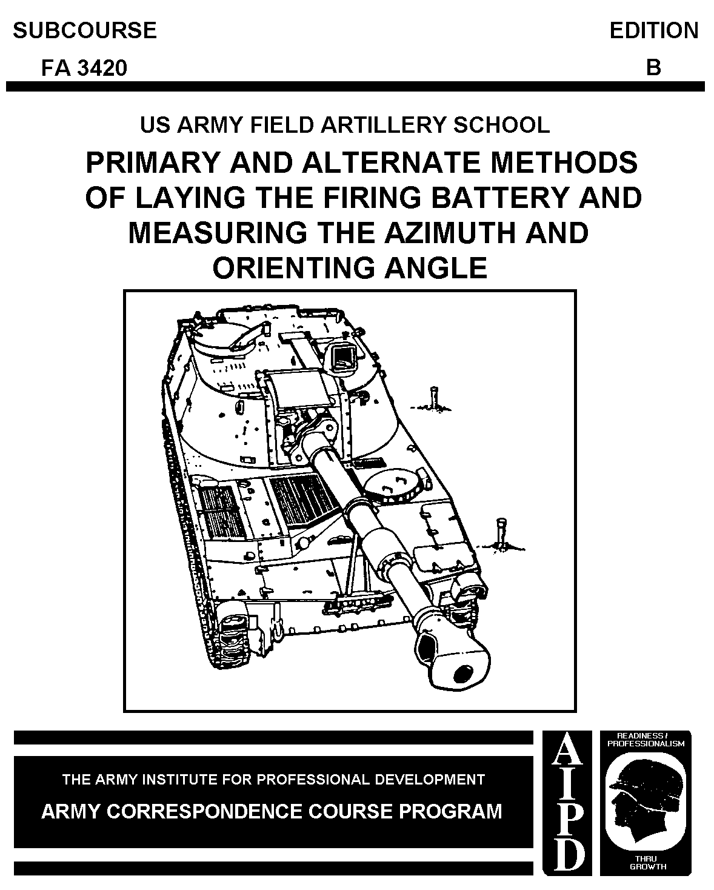

CANNON CREW MEMBER
MOS 13B SKILL LEVEL 4

PRIMARY AND ALTERNATE METHODS OF LAYING THE FIRING BATTERY
AND MEASURING THE AZIMUTH AND ORIENTING ANGLE

Subcourse FA 3420

EDITION B

United States Army Field Artillery School
Fort Sill, Oklahoma

Five Credit Hours

Edition Date: January 2005

SUBCOURSE OVERVIEW

This subcourse is designed to train the skills necessary for performing tasks related to laying the firing battery or platoon, using the azimuth and orienting angle. The subcourse is presented in six lessons, each lesson corresponding to a terminal learning objective supporting the following soldier's manual tasks:

TASK NO: 061-266-4000 TASK N0: 061-266-4001

TASK NO: 061-266-4003 TASK NO: 061-266-4004

TASK NO: 061-266-4145 TASK NO: 061-266-4146

TASK NO: 061-266-4147 TASK NO: 061-266-4148

TASK NO: 061-266-4149 TASK NO: 061-266-4151

TASK NO: 061-266-4152

There are no prerequisites for this subcourse.

This subcourse reflects the doctrine which was current at the time it was prepared. In your own work situation, always refer to the latest official publications.

Unless otherwise stated, the masculine gender of singular pronouns is used to refer to both men and women.

Terminal Learning Objective:

Gain the knowledge and skills required to determine and employ the appropriate primary and alternate methods of laying the platoon or firing battery, and measuring the azimuth and orienting angle.

ACTION: Acquire the knowledge and skills required to set up, declinate and march order an M2/M2A2 aiming circle; declinate and use an M2 compass to lay a
platoon/battery; lay a platoon/battery with the M2/M2A2 aiming circle using the orienting angle and grid azimuth methods of lay; measure the azimuth and orienting angle; and lay a platoon/battery using the aiming point-deflection and howitzer back-lay methods.

CONDITION: Given the material contained in this subcourse.

STANDARD: Attain a minimum score of 70% on the examination at the end of the
subcourse.

REFERENCES: The material contained in this subcourse was derived from FM 6-50
and other materials approved for US Army field artillery instruction.

TABLE OF CONTENTS

Table of Contents

Subcourse Overview

Lesson 1: The M2/M2A2 Aiming Circle

Practice Exercise

Answer Key and Feedback

Lesson 2: Laying By Orienting Angle Method

Practice Exercise

Answer Key and Feedback

Lesson 3: Laying By Grid Azimuth Method

Practice Exercise

Answer Key and Feedback

Lesson 4: Laying By M2 Compass Method

Practice Exercise

Answer Key and Feedback

Lesson 5: Laying By Aiming Point And Deflection Method

Practice Exercise

Answer Key and Feedback

Lesson 6: Laying By Howitzer Back-Lay Method

Practice Exercise

Answer Key and Feedback

EXAMINATION

LESSON 1

THE M2 AIMING CIRCLE

OVERVIEW

LESSON DESCRIPTION:

This lesson teaches how to set up, level, declinate, and march order the M2/M2A2 aiming circle.

LEARNING OBJECTIVE:

ACTION: Identify the procedures for setting up, leveling, declination, and
march order of the M2/M2A2 aiming circle.

CONDITION: Given the material contained in this lesson.

STANDARD: Correctly answer all questions on the practice exercise at the end
of the lesson.

REFERENCES: The material contained in this lesson was derived from FM 6-50 and
other material approved for US Army field artillery instruction.

INTRODUCTION

As an artilleryman you must know how to correctly set up, level, declinate and march order the circle. Once you have mastered these tasks, you can then orient the aiming circle on the line of fire and lay the firing battery. If you are already familiar with the nomenclature and characteristics of the aiming circle,
this lesson will serve as a refresher.

Aiming Circle.

1. General. The M2/M2A2 aiming circle is a small, light-weight instrument used in the field artillery firing battery and survey section. The instrument is the primary means of orienting the cannon battery or laying its weapons on the azimuth of fire. It is normally operated by the executive officer, platoon
sergeant, or gunnery sergeant.

Instrument operators within the survey section use the aiming circle to measure horizontal and vertical angles.

2. Components. The major components of the aiming circle include: the aiming circle cover, aiming circle, plumb bob, tripod assembly, and night light. Study Figures 1-1 and 1-2 to become familiar with the names and location of the components.
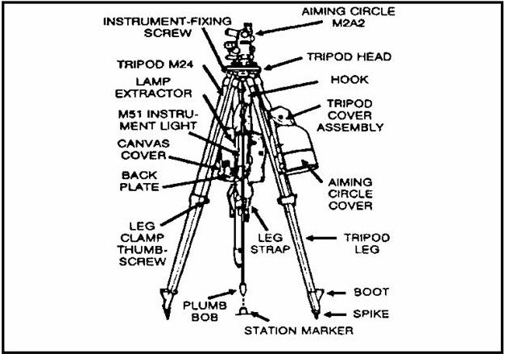

Figure 1-1. Aiming Circle with Accessory Equipment.

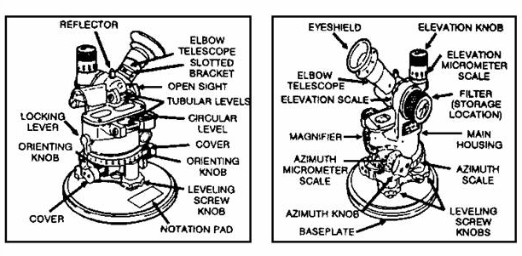

Figure 1-2. Left and Right Side View of Airming Circle.

NOTE: The M2 and the M2A2 aiming circle operate in the same manner. All characteristics are the same except elevation movement. The M2A2 model allows an additional 300 mils of elevation movement. The maximum elevation for the M2 is 800 mils. The maximum elevation for the M2A2 is 1100 mils. The minimum elevation for each model is minus 400 mils. Figure 1-3 shows that the elevation
micrometer knob and scale differ, and the magnetic needle cover has been changed on the M2A2 to allow for greater maximum elevation.
a. Aiming Circle Components.

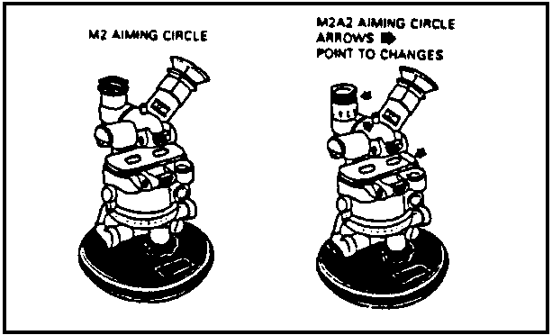

Figure 1-3. M2 and M2A2 Aiming Circles.

- Telescope. The telescope is a four-power, fixed-focus optical instrument with a reticle pattern like the ones shown in Figure 1-4.

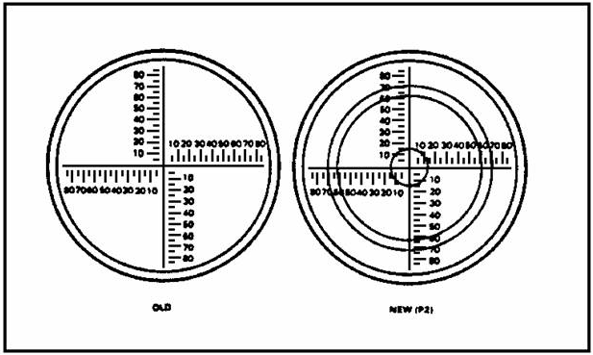

Figure 1-4. Telescope Reticles.

NOTE: Some aiming circles may not be equipped with the P-2 reticle pattern (National Stock Number [NSN] 1240-01-152-8516) used to perform the Polaris 2 Method of hasty survey. This modification can be made at Direct Support Maintenance.

- Reflector. The reflector (Figure 1-2) is a plastic signal post located on top of the telescope. It is mounted directly over the center of traverse and is used as an aiming point for other instruments to site on.

- Elevation Knob. The elevation knob (Figure 1-2) is used to raise and lower the telescope line of sight. It is also used to measure vertical angles.

- Elevation Scale. Each graduation on the elevation scale (Figure 1-5) represents 100 mils. The scale is numbered at 100 mil intervals. The black numbers 0 to 1100 indicate elevation (+). The red 0 to 400 numbers indicate depression (-).

- Elevation Micrometer Scale. Each graduation on the elevation
Micrometer scale (Figure 1-5) represents 1 mil. The scale is
numbered at 10-mil intervals. The black numbers 0 to 100
indicate elevation (+). The red numbers 0 to 100 indicate
depression (-). The elevation micrometer scale can be visually
interpolated to the nearest .5.

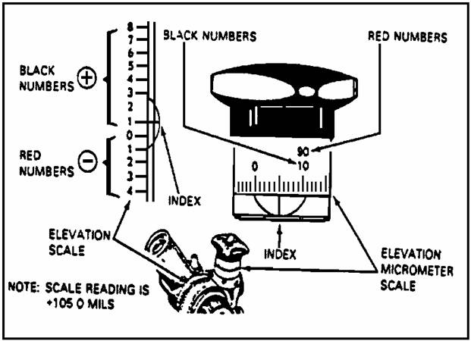

Figure 1-5. Elevation and Elevation Micrometer Scales.

- Magnetic Compass. The magnetic compass is located in the main housing (Figure 1-2). For rough centering, the magnetic needle may be seen through the windows on top of the body assembly. A small glass magnifier (Figure 1-2) and reticle with three vertical lines (Figure 1-6) are at one end of the recess. These aid in aligning the end of the magnetic needle.

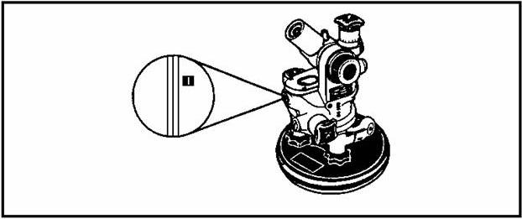

Figure 1-6. Magnetic Compass.

- Leveling Vials. There are two tubular leveling vials and one circular leveling vial (Figures 1-2 and 1-7) on the aiming circle. One tubular leveling vial (on the left side of the elbow telescope) is used in leveling the telescope so the operator can measure vertical angles. The other tubular leveling vial (on the left side of the main housing), or the circular leveling vial (fisheye bubble) is used in leveling the aiming circle for measuring horizontal angles. When the tubular leveling vials are not in use, the protective covers should be closed to prevent damage.

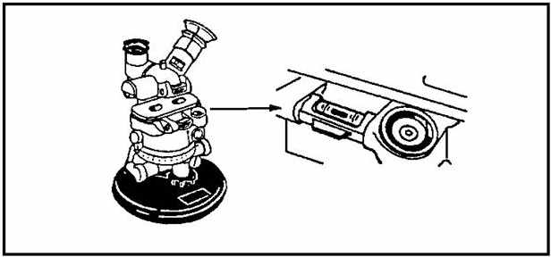

Figure 1-7. Leveling Vials.

.....b. Azimuth and Azimuth Micrometer Scales.

- Azimuth and Azimuth Micrometer Scales.

- The azimuth scale (Figure 1-2) is located below the magnetic compass housing. It is graduated (Figure 1-8) in 100- mil increments from 0 to 6400 mils and is numbered every 200 mils. The portion of the azimuth scale from 3200 mils through 6400 mils has a second 0-3200 mil scale numbered in red from the black 32 through the large black 0 on the azimuth scale. This scale cannot be interpolated to the nearest .5 il.

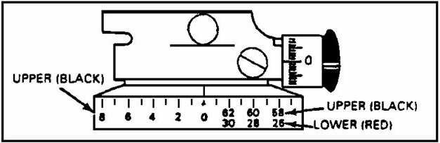

Figure 1-8. Azimuth Scales.

NOTE: The azimuth scale is also an imaginary line called the 0-3200 line. This starts at the black 0 and goes through the black 32 on the scale. This is the line oriented on the azimuth of fire during the laying process.

- On the azimuth scale, the red numbers 0 to 3200 indicate azimuth. The lower row of graduations parallels the 3200- to 6400-mil upper row of Graduations. This permits the aiming circle to be used with other instruments that have scales graduated 0 to 3200 mils. The red numbers are only used in one of the following instances.

--When you are reading (deflection) red numbers to an M12-series sight.

--When you are checking the lay of one aiming circle with another (checking the operation of the lay circle with the safety circle). The operator of only one of the two circles will see the red scales. The red scales are read to preclude adding or subtracting 3200 to or from the reading.

  - The azimuth micrometer scale (Figure 1-2) is located on the azimuth knob on the lower right side of the magnetic needle housing. It is graduated (Figure 1-9) in 1-mil increments from 0 to 100 mils and is numbered every 10 mils. This scale can be read to an accuracy of 0.5 mil.

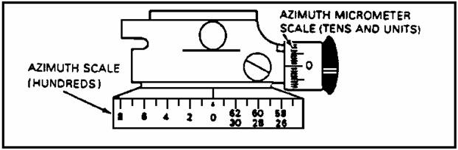

Figure 1-9. Azimuth Micrometer Scale.

- Upper (Recording) Motion. The upper motion allows the operator to place values on the azimuth and azimuth micrometer scales by the means of the azimuth knob (Figure 1-2). The values are read on the scale index, which is located below the magnetic needle magnifier. The upper motion of the instrument has both a fast motion and a slow motion. Pulling back on the azimuth knob enables fast motion. Rotation of the azimuth knob produces slow motion. Horizontal angles are read in two parts--hundreds of mils are read from the azimuth scale, and tens and units of mils are read from the azimuth micrometer scale.

- Lower (Non-recording) Motion. The lower motion is controlled by the orienting knobs (Figure 1-2). The orienting knob is used to orient the 0-3200 line of the aiming circle without changing the values on the upper motion. Lateral movement of one orienting knob enables fast movement of the lower motion of the aiming circle. The two orienting knobs should be used at the same time for slow movement of the lower motion. Caps that cover the orienting knobs prevent unintentional use of the lower motion.

- Leveling Screw Knobs. The three leveling screw knobs (Figure 1-2) are used to level the aiming circle. They are on a spring plate located below the orienting knobs and above the baseplate assembly.

- Base Plate Assembly. The Base Plate Assembly (Figure 1-2) serves as the base of the instrument, when the instrument is mounted on the tripod and serves as the base for the carrying case. The Base Plate is a flat circular plate to which the instrument is attached by means of the spring plate. An instrument-fixing screw is threaded into a socket on the underside of the baseplate assembly to attach the instrument to the tripod. The socket is kept clean and free of obstruction by a spring-loaded cover that stays closed when the instrument is not attached to the tripod. The baseplate is fitted with a rubber gasket that forms a watertight seal when the cover is latched to the baseplate.

- Notation Pad. A rectangular notation pad (Figure 1-2)on the baseplate is used for recording the declination constant, date of declination, vertical angle correction, and initials of the person performing the declination.

- Filter. The filter (Figure 1-2) is a lens which is placed over the telescope for protection against the rays of the sun. It is stored on the cover side of the telescope body. It is held in place by a spring-loaded ball.

- Eye Shield. The eye shield (Figure 1-2) is a rubber piece that fits over the viewing end of the telescope. It has several perforated holes to prevent suction around the eye. The primary purpose of the shield is to block outside light so a better sight picture can be obtained.

- Compass Needle Locking Lever. When the locking lever (Figure 1-2) is in a vertical position, the needle is locked. When the lever is turned either right or left to a horizontal position, the needle is unlocked. To preclude damage to the magnetic needle, this lever should be returned to the locked position gently.

CAUTION: THE NEEDLE MUST BE LOCKED WHEN IT IS NOT IN USE.

c. Setting Up The Aiming Circle.

- To set up the aiming circle, (Figure 1-10) follow these procedures:

- Unstrap the legs of the tripod, loosen the leg clamp thumbscrews,and extend the legs to the desired length. Tighten the leg clamp thumbscrews.

- Place the tripod over the point to be occupied (Orienting Station[OS]). One tripod leg should be pointing in the approximate direction of sighting, and the leg with the night-light mount should be to the operator's left. Attach the plumb bob to the hook under the instrument-fixing screw assembly. The plumb bob should be within a 1-inch radius of the station marker.

- Firmly embed the tripod spikes with your boot. Make sure the tripod head is approximately level when the spikes are embedded, then remove the tripod head cover.

- Pull back the spring-loaded cover on the base plate, and place the aiming circle on the tripod. Loosely screw the instrument-fixing screw assembly into the base plate.

- Center the plumb bob over the orienting station by moving the base plate of the aiming circle.

- Tighten the instrument-fixing screw assembly into the base plate of the aiming circle.

CAUTION: Be careful not to exert excessive pressure when you are tightening the instrument-fixing screw. The slotted arm may bend and damage the tripod head.

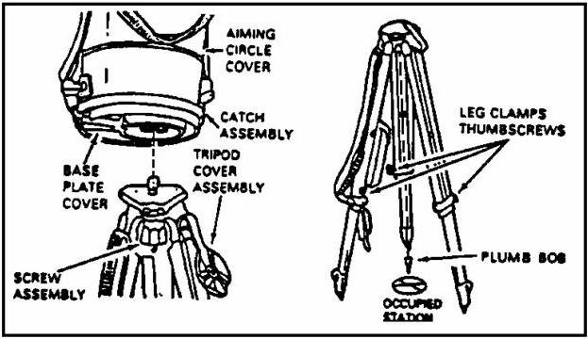

Figure 1-10. Tripod With Aiming Circle Assembly.

- Remove the aiming circle head cover, and hang it on the tripod head cover or a leg clamp thumbscrew to prevent damage.

- Install the M51 night-light device accessory case if necessary.

d. Leveling the aiming circle. There are two methods of leveling the aiming circle for normal use. Either the circular leveling vial or the tubular vial (Figure 1-11) can be used.

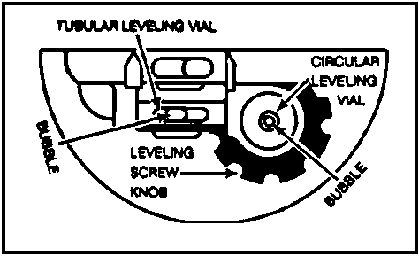

Figure 1-11. Leveling Vials.

- The preferred method is to level the aiming circle by using the circular leveling vial (fisheye bubble) as follows:

- Loosen the leveling screws approximately halfway.

- Rotate the head of the aiming circle until the circular leveling vial is over the leveling screw adjacent to the notation pad.

- Using the thumb and forefinger of each hand, turn the other two leveling screws in the opposite direction. The bubble will move in the same direction as the left thumb.

- When the bubble moves on line with the fisheye, center the bubble by using only the third leveling screw. Rotate the head of the instrument over the other two screws. If more than half the bubble moves out of the center ring, relevel the instrument. If the bubble cannot be centered with the fisheye, use the tubular leveling vial as discussed in the paragraph below.

- Level the circle by using the tubular leveling vial as follows:

- Loosen the three leveling screws approximately halfway. Rotate the instrument until the axis of the tubular leveling vial is parallel to any two of the leveling screws. Center the bubble by using these two leveling screws. Grasp a leveling screw between the thumb and forefinger of each hand. Turn the screws simultaneously so that your thumbs move either toward each other or away from each other. This movement tightens one screw as it loosens the other. The bubble always moves in the same direction as the left thumb.

- Rotate the instrument 1600 mils, and center the bubble by turning the third leveling screw.

- Rotate the instrument back to the first position, and relevel the bubble if necessary.

- Repeat these steps until the bubble remains centered in both positions.

- Rotate the instrument 3200 mils from the first position. If the bubble remains centered in this position, rotate the instrument 3200 mils from the second position. If the bubble remains centered, the instrument is level. If the bubble does not remain centered when the instrument is rotated 3200 mils from the first position, the leveling vial is out of adjustment. To compensate, use the same leveling screws that placed the instrument in the first position, and move the bubble halfway back to the center of the leveling vial. The instrument is now level, and the bubble should come to rest in its vial at the same off-center position (within one graduation) regardless of the direction in which the instrument is pointed. If the leveling vial is out of adjustment, the instrument should be turned in for repair at the earliest opportunity.

e. Declinating the Aiming Circle.

- A declination constant (Figure 1-12) is defined as the horizontal clockwise angle measured from grid north to magnetic north. The declination constant is recorded for all instruments equipped with a magnetic compass.

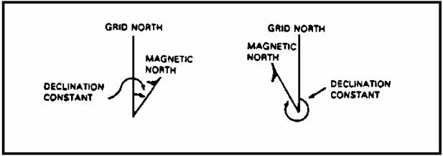

Figure 1-12. Declination Constant.

- Declination of an aiming circle is the process of aligning the instrument's magnetic compass with magnetic north, then determining the angular difference between grid north and magnetic north. A minimum of two computations must be made.

- The aiming circle must be declinated when any of the following situations exist:

- After an electrical storm.

- Anytime the instrument receives a severe shock. (Example: If it is dropped from the bed of a truck to the ground.) The magnetic needle is a delicately balanced mechanism, and shock may cause a significant change in the declination constant.

- Anytime the aiming circle is moved 25 miles or more from the area in which it was last declinated. Because of local magnetic attractions, any movement of the aiming circle may result in an appreciable change in the relationship of grid north and magnetic north, as measured by the instrument.

- At least every 30 days to determine if any changes in the declination have occurred because of the annual shift of magnetic north, or because of accidents involving the instrument that may not have been reported. If a radical change is observed the instrument should be declinated again within a few days to determine if the observed change is a real change in the characteristics of the instrument.

- When the instrument is first received.

- Anytime the instrument has been turned in for repair.

- The aiming circle must be declinated in an area free from magnetic attractions. Azimuths must be known to two or more azimuth marks (aiming points), preferably in opposite directions. These azimuth marks should be at a minimum distance of 300 meters, preferably 1000 meters.

- Declinate the aiming circle as follows:

- Set up and level the aiming circle over the declination station.

- With the upper (recording) motion, set the known azimuth to the azimuth marker.

- With the lower (non-recording) motion, sight on the azimuth marker (Figure 1-13) that corresponds to the azimuth set with the upper motion.

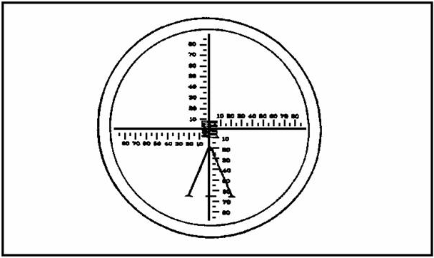

Figure 1-13. Proper Sight Picture.

NOTE: At this time, the 0-3200m line will be aligned with grid north (GN).

- Release the magnetic needle. With the upper motion, float and center (Figure 1-14) the magnetic needle

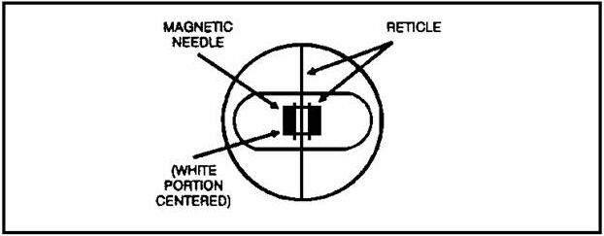

Figure 1-14. Magnetic Needle.

- Read the declination constant directly from the scales (to the nearest 0.5 mils).

- Using a second azimuth, repeat the steps. If a second azimuth marker is not available, use the first marker again.

- Compare the two declination constants. If they agree within ± 2 mils, determine the mean (average). Express it to the nearest whole mil by using standard artillery expression. On the notation pad record the mean (four-digit number [Example 0186]), the date, and the initials of the individual performing the declination.

NOTE: If the two values differ by more than ± 2 mils, repeat the entire process.

- Declination can be performed by scaling a grid azimuth to two distant points. The following procedures are used:

- Place and level the aiming circle over the selected point.

- Locate your position and two distant points on the map. Scale the direction to each of these points from the occupied point.

- Using the directions scaled from the map, declinate the aiming circle using the procedures previously discussed.

- Compare the two values determined. They must agree within ± 10 mils.

- If the values agree within ± 10 mils, determine the mean; record it on the notation pad. If the values do not agree within ± 10 mils, repeat the entire procedure.

f. Taking Down (March Order) The Aiming Circle. To march order the aiming circle use the following steps:

- Elevate the telescope to about 300 mils.

- Ensure the magnetic needle is locked.

- Cover the tubular leveling vials.

- Be sure the instrument light is turned off and secured in its case.

- Ensure the caps of the orienting knobs are closed.

- Place the azimuth knob over the notation pad.

- Turn the leveling screws counterclockwise until the screws are to their lower stops, then back off ^{1/4} turn to prevent seizure during temperature change.

- Place the carrying case over the aiming circle, and latch the cover locks.

- Remove and secure the plumb bob if attached.

- Unscrew the instrument-fixing screw and remove the instrument from the tripod.

- Replace the tripod head cover.

- Retract and collapse the tripod legs, and tighten the thumbscrews.

- Strap the tripod legs together.
LESSON 1

PRACTICE EXERCISE

The following items will test your knowledge of the material covered in this lesson. There is only one answer for each item. When you have completed the exercise, check your answer with the key that follows. If you answer any item incorrectly, study again that part which contains the portion involved.

1. The instrument used as the primary means of orienting the cannon battery or platoon is the--

A. T-16 Theodolite.

B. M2/M2A2 Aiming Circle.

C. M2 Compass.

2. The aiming circle component shown at the end of the arrow in figure PE 1-1 is the--

A. azimuth strip.

B. nomenclature plate.

C. notation pad.

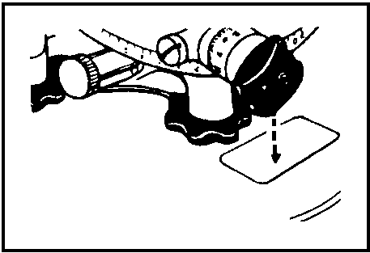

Figure PE 1-1.

The next three questions are based on Figure PE 1-2.

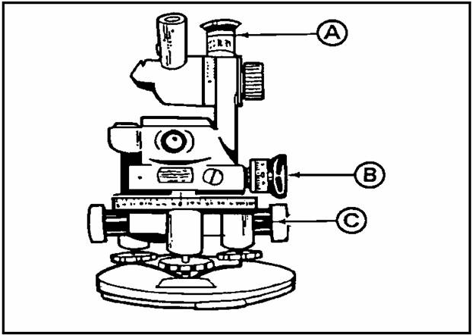

Figure PE 1-2.

3. The aiming circle component identified by "A" above is the--

A. azimuth knob.

B. orienting knob.

C. elevation knob.

4. The aiming circle component identified by "B" above is the--

A. azimuth knob.

B. elevation knob.

C. orienting knob.

5. The aiming circle component identified by "C" above is the--

A. elevation knob.

B. orienting knob.

C. azimuth knob.

6. The azimuth micrometer scale can be read through interpolation to an accuracy of--

A. 0.1 mil.

B. 0.5 mil.

C. 1.0 mil.

7. When placing the tripod over the station, one leg should be pointed--

A. toward the rear of the battery.

B. toward the Number 3 howitzer.

C. in the approximate direction of the sighting.

8. The tripod is set up and ready when the legs are firmly embedded in the ground and the plumb bob is within a--

A. one inch radius of the station marker.

B. one-half inch radius of the station marker.

C. one-fourth inch radius of the station marker.

9. The declination constant is the horizontal clockwise angle measured from--

A. magnetic north to grid north.

B. true north to grid north.

C. grid north to magnetic north.

D. magnetic north to true north.

10. Normally, an aiming circle should redeclinated every--

A. 3 days.

B. 7 days.

C. 30 days.

D. 90 days.

11. During march order of the aiming circle, the azimuth knob is placed over the--

A. notation pad.

B. first leveling screw.

C. third leveling screw.

12. During march order of the aiming circle, the magnetic needle must be--

A. removed.

B. locked.

C. installed.

D. unlocked.

PART 1

PRACTICE EXERCISE

ANSWER KEY AND FEEDBACK

ITEM Correct Answer and Feedback

1. B. para 1.

2. C. Figure 1-2.

3. C. Figure 1-2.

4. A. Figure 1-2.

5. B. Figure 1-2.

6. B. para 2b.

7. C. para 2c.

8. A. para 2c.

9. C. para 2e.

10. C. para 2e.

11. A. pagepara 2f.

12. B. para 2f.

/////////////////////////////////////////////////////////////////

2. Summary. The information presented in this lesson dealt with procedures for setting up, declinating and march ordering the aiming circle. As a field artilleryman you must be thoroughly familiar with each of the areas, to effectively lay a firing battery or platoon and measure required azimuths. Ensure that you understand all the information in this lesson before
proceeding to Lesson number 2.
LESSON 2

LAYING THE FIRING BATTERY USING THE M2/M2A2 AIMING CIRCLE
BY THE ORIENTING ANGLE METHOD

OVERVIEW

LESSON DESCRIPTION:

This lesson teaches the procedures for laying the platoon/battery using the M2/M2A2 aiming circle, by the orienting angle method.

LEARNING OBJECTIVE:

ACTION: Identify the procedures for laying the battery using the M2/M2A2
aiming circle, by the orienting angle method.

CONDITION: Given the material contained in this lesson.

STANDARD: Correctly answer all questions on the practice exercise at the end
of the lesson.

REFERENCES: Material contained in this lesson was derived from FM 6-50 and
other material approved by the US Army field artillery
instruction.

INTRODUCTION

The most accurate way to lay any artillery firing battery or platoon is by using the orienting angle (OA) method. To use this method, there must be accurate survey to a known point in the battery position area. The known azimuth (orienting line) to a point is normally established by the battalion survey section before the battery moves into position.

1. Locating the end of the orienting line and determining the orienting angle.

a. Within the battery/platoon position, the aiming circle operator is usually the battery executive officer, the chief of firing battery, or the gunnery sergeant. The azimuth (AZ) to the end of the orienting line (EOL) may be provided by the survey section, or it may be found on a tag attached to a stake marking the OS (Figure 2-1).

b. Set up the aiming circle as previously described in lesson 1, ensuring the plumb bob is over the OS. A large stake (Figure 2-1) next to the OS should point the general direction to the EOL.

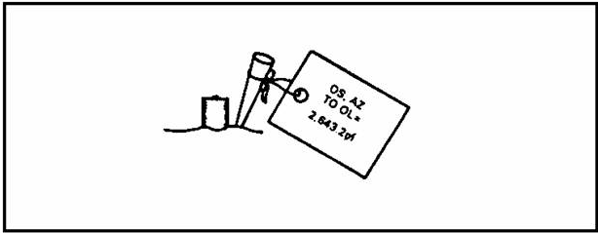

Figure 2-1. Marked Orienting Station.

c. Now that the aiming circle is set up and level, determine the OA. To accomplish this, subtract the azimuth of fire from the azimuth of the OL. The azimuth of fire will be given by the battery commander or higher headquarters. If the azimuth of fire is the larger figure, add 6400 to the azimuth of the OL before subtracting. The difference between the two figures is the orienting angle (Figure 2-2).

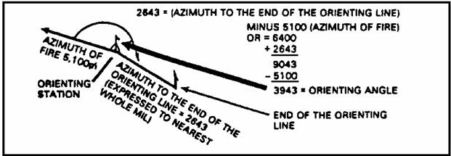

Figure 2-2. Orienting Angle.

2. Orienting the aiming circle.

a. After you have determined the OA, orient the 0-3200 line of the aiming circle in the direction of fire. Rotate the orienting knob (LOWER MOTION) until the single 0 on the azimuth scale is directly in front of you as you look in the direction of fire (Figure 2-3). The single 0 represents the breech end of the weapon and the small 0 over the 32 represents the muzzle.

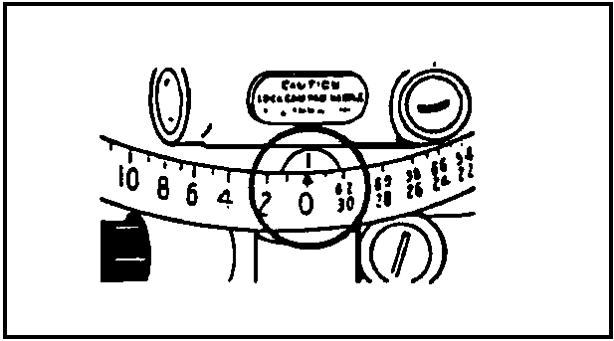

Figure 2-3. AZ Scale at Zero.

b. Use the azimuth knob (UPPER MOTION) to place the value of the OA on the aiming circle. Use the black numbers on the azimuth scale for the first two numbers of this reading; the second two numbers are placed on the azimuth micrometer scale (Figure 2-4).

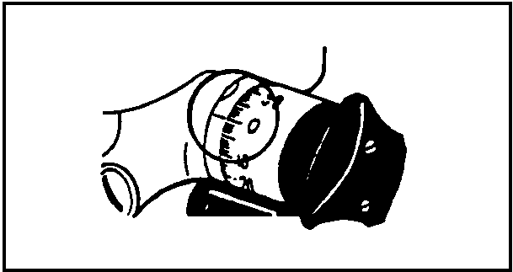

Figure 2-4. Azimuth Micrometer Scale.

c. Using the orienting knob (LOWER MOTION), sight on the EOL (Figure 2-5).

NOTE: Align the vertical line of the reticle pattern on the left edge of the EOL unless directed to do otherwise).

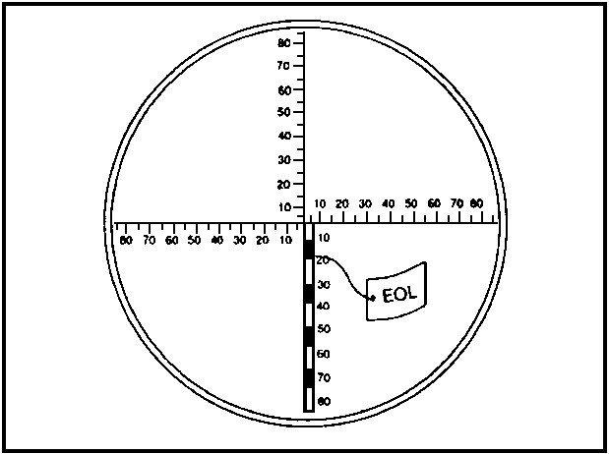

Figure 2-5. Sighting on the EOL.

3. Using correct commands to lay the battery.

a. There are various commands that must be used to lay the battery. Once you have sighted on the EOL with the aiming circle, use the command "BATTERY ADJUST, AIMING POINT THIS INSTRUMENT." This commands the gunners to sight on the aiming circle (with the howitzer panoramic telescopes [pantel]) and to
prepare to lay the howitzers for direction.

- After receiving this command, each howitzer gunner identifies the aiming point (aiming circle) by announcing "NUMBER(so-and-so), AIMING POINT IDENTIFIED." Gunners identify the aiming point as soon as they locate it through the panoramic telescope. No order of precedence is established for the howitzers to report. The purpose of this is to save time. (Howitzer number 3 is used in the following examples).

- Once you receive the response "NUMBER 3, AIMING POINT IDENTIFIED," look through the eyepiece of the aiming circle and use the azimuth knob to sight on the pantel (Figure 2-6) of the number 3 howitzer.

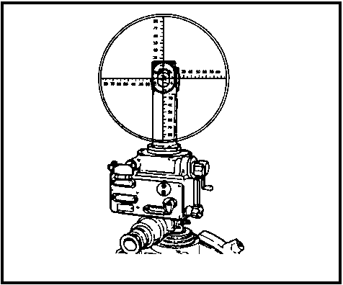

Figure 2-6. View of Howitzer Panoramic Telescope.

- Always read the first two numbers of deflection from the azimuth scale and the last two numbers from the azimuth micrometer scale (Figure 2-7).

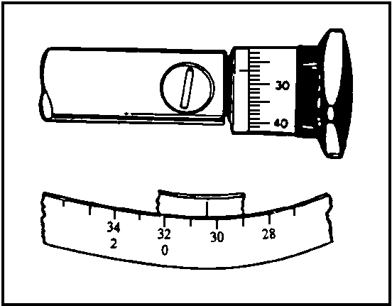

Figure 2-7. Placing the IR on the Airming Circle.

- If the howitzers are equipped with the M12-series sight, use the red numbers on the azimuth scale whenever they appear under the scribe mark on the aiming circle.

- Use the command (in this example) "NUMBER 3 DEFLECTION 3027," to announce the deflection to the gunner of the number 3 howitzer.

- The gunner repeats the command "NUMBER 3, DEFLECTION 3027," sets this deflection on his sight, and traverses the tube until he has a correct sight picture on the aiming circle. He ensures the bubbles are level and the sight picture is correct. He then responds "NUMBER 3, READY FOR RECHECK."

- To recheck the deflection to the howitzer, realign the vertical cross hair in the reticle pattern of the pantel. Announce the deflection to the gunner using the command "NUMBER 3, DEFLECTION 3024." Continue this exchange with the number 3 gunner until a difference of 0 mils is obtained. After a difference 0 mils is obtained, the gunner announces it using the response "NUMBER 3, DEFLECTION 3024, 0 MILS." Once a correction of 0 mils is achieved, the gunner makes no further corrections. At this time, command "NUMBER 3 IS LAID."

b. Normally, you would read deflections to the gunners in the order they have identified themselves to the aiming point, however, once a difference of less than 10 mils is obtained, continue to make corrections to that piece until it is laid. Once you have completed laying all pieces in the battery, announce "THE BATTERY IS LAID." Replace the cover over the aiming circle, and make a visual check to ensure the howitzer tubes are parallel. If time permits, have the gunners make a reciprocal check to ensure the tubes are parallel.

c. The procedures for reciprocal laying will be discussed in paragraph 7 of lesson 4.

LESSON 2

PRACTICE EXERCISE

The following items will test your knowledge of the material covered in this lesson. There is only one answer for each item. When you have completed the exercise, check your answer with the key that follows. If you answer any item incorrectly, study again that part which contains the portion involved.

1. The most accurate method of laying the battery is the--

A. orienting angle method.

B. grid azimuth method.

C. M2 compass method.

D. howitzer back-lay method.

2. The orienting line is normally established by --

A. the howitzer gunner.

B. the battery survey section.

C. the battalion survey section.

D. the fire direction center (FDC) station.

3. The orienting line normally is established--

A. after departure of the battery.

B. upon arrival of the battery.

C. after the battery has fired.

D. before the battery arrives.

4. When survey has been established, the azimuth to the EOL may be found--

A. on a tag attached to a marking stake.

B. written on the notation pad.

C. on a tag attached to the EOL marker.

5. The large stake located at the OS points in the general direction of the--

A. aiming circle location.

B. howitzer locations.

C. azimuth to the EOL.

6. To compute the orienting angle--

A. subtract the azimuth to the EOL from the azimuth of fire.

B. subtract the azimuth of fire from the declination constant.

C. subtract the azimuth of fire from the azimuth of the OL.

D. read the angle from the tag on the marking stake.

7. If the azimuth of fire is larger than the azimuth of the OL, you must add 6400 to the ____________ before subtracting.

A. azimuth of fire.

B. azimuth to the OL.

C. azimuth to the howitzers.

In items 8-12 below, you are provided with the azimuth of fire and the azimuth to the EOL. Compute the orienting angle for each item.

AZIMUTH OF FIRE AZIMUTH TO EOL ORIENTING ANGLE

8. 6350 1727 ______________m

9. 1700 4523 ______________m

10. 4000 3923 ______________m

11. 3550 4257 ______________m

12. 2000 1875 ______________m

13. To orient the 0-3200 line of the aiming circle in the direction of fire after placing the orienting angle on the azimuth scales, use the--

A. elevation knob.

B. orienting knobs.

C. azimuth knob.

14. As you look in the direction of fire after orienting the 0-3200 line of the aiming circle, you should be facing--

A. the number 0 on the azimuth scale.

B. the number 3200 on the elevation scale.

C. the number 6400 on the elevation scale.

15. When placing the value of the OA on the aiming circle, use the--

A. elevation knob.

B. orienting knob.

C. azimuth knob.

16. When placing the value of the orienting angle on the azimuth and azimuth micrometer scales, you should use the--

A. red and black numbers.

B. red numbers only.

C. black numbers only.

17. When you are laying the battery by OA and you wish to sight on the EOL, use the--

A. azimuth knob.

B. orienting knob.

C. elevation micrometer knob.

18. Always align the vertical line of the telescope reticle on the--

A. top center of the EOL.

B. right edge of the EOL.

C. left edge of the EOL.

19. What command is given by the aiming circle operator in preparation for laying the firing battery?

A. PREPARE TO BE LAID.

B. BATTERY ADJUST, AIMING POINT THIS INSTRUMENT REFER.

C. BATTERY ADJUST, DEFLECTION 3180.

D. BATTERY ADJUST, AIMING POINT THIS INSTRUMENT.

20. The correct response in question number 19 commands the gunners to--

A. remove the tube out of travel lock.

B. sight on the aiming circle.

C. elevate the tube.

D. emplace the collimator.

21. After the gunner identifies the aiming circle through his sight, he announces--

A. NUMBER (so-and-so), DEFLECTION (so much).

B. NUMBER (so-and-so), READY FOR RECHECK.

C. NUMBER (so-and-so), O MILS.

D. NUMBER (so-and-so), AIMING POINT IDENTIFIED.

22. To sight on the howitzer pantel with the aiming circle, use the--

A. elevation knob.

B. orienting knob.

C. azimuth knob.

D. leveling knob.

23. To announce a deflection of 4510 to howitzer number 5, command--

A. DEFLECTION 4510, NUMBER 5.

B. NUMBER 5, DEFLECTION 4510.

C. NUMBER 5, DEFLECTION 4510, REFER.

24. Use the red numbers on the aiming circle azimuth scale when laying a howitzer equipped with--

A. M12-series sights.

B. M16-series sights.

C. M26-series sights.

D. M100-series sights.

25. After laying all the howitzers in the battery, your command is----

A. BASE PIECE IS LAID.

B. NUMBER 5 IS LAID.

C. THE BATTERY IS LAID.

D. BATTERY THE BASE PIECE is LAID.

26. Place the following steps used in laying by orienting angle in the correct sequence.

________ A. Command BATTERY ADJUST, AIMING POINT THIS INSTRUMENT.

________ B. Use the azimuth knob to place the orienting angle on the
aiming circle.

________ C. Use the plumb bob to set up the aiming circle over the OS.

________ D. Gunner responds NUMBER (so-and-so), AIMING POINT IDENTIFIED as
he locates the aiming circle.

________ E. Determine the direction to the EOL from the OS.

________ F. Use the azimuth knob to sight on the pantel.

________ G. Orient the 0-3200 line in the direction of fire.

________ H. Announce deflections to each gunner.

________ I. Use the orienting knob to sight on the EOL.

________ J. Command THE BATTERY IS LAID.

LESSON 2

PRACTICE EXERCISE

ANSWER KEY AND FEEDBACK

ITEM Correct Answer and Feedback

1. A. Intro.

2. C. Intro.

3. D. Intro.

4. A. para 1a.

5. C. para 1b.

6. C. para 1c.

7. B. para 1c.

8. 1777 para 1c.

9. 2823 para 1c.

10. 6323 para 1c.

11. 0707 para 1c.

12. 6275 para 1c.

13. B. para 2a.

14. A. para 2a.

15. C. para 2b.

16. C. para 2b.

17. B. para 2c.

18. C. para 2c.

19. D. para 3a.

20. B. para 3a.

21. D. para 3a.

22. C. para 3a.

23. B. para 3a.

24. A. para 3a.

25. C. para 3b.

26. C., E., G., B., I., A., D., F., H., J.,

/////////////////////////////////////////////////////////////////

4. Summary. The information presented in this lesson dealt with the procedures for laying the firing battery with the M2 aiming circle when survey is available. Correct procedures for orienting the aiming circle, as well as the correct commands for laying the firing battery, are essential in firing battery operations. Ensure that you understand all the information in
this lesson before continuing to Lesson 3.

LESSON 3

LAYING THE FIRING BATTERY BY THE GRID AZIMUTH METHOD
MEASURING THE AZIMUTH AND ORIENTING ANGLE

OVERVIEW

LESSON DESCRIPTION:

This lesson teaches the procedures for laying the firing battery/platoon by the grid azimuth method, and measuring the azimuth and orienting angle.

LEARNING OBJECTIVE:

ACTION: Identify the procedures for laying the firing battery using the
grid azimuth method of laying, and the procedures for measuring
the azimuth and orienting angle.

CONDITION: Given the material contained in this lesson.

STANDARD: Correctly answer all questions on the practice exercise at the end
of the lesson.

REFERENCES: Material contained in this lesson was derived from FM 6-50 and
other material approved for US Army Field Artillery instruction.

INTRODUCTION

If survey data is not available and hasty survey is not possible, another method must be used to lay the battery. The second best method of orienting the aiming circle is the grid azimuth method.

1. Aiming Circle Location.

a. Laying by grid azimuth involves the use of the magnetic needle of the aiming circle. The instrument must be set up where it is free from magnetic attractions. The minimum distances are as follows:

- 150 meters from power lines and electronic equipment.

- 75 meters from railroad tracks, artillery, tanks, vehicles, or ammunition.

- 10 meters from barbed wire, personal weapons, and small metallic objects.

b. The aiming circle should be set up in a position where all gunners can easily locate it through the pantels of their howitzers (Figure 3-1). This is usually to the left front of the battery. The left rear may be utilized if all howitzer sights cannot be seen from the left front.

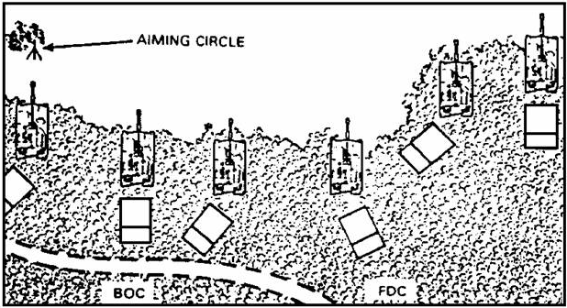

Figure 3-1. Aiming Circle Location.

2. Declination Constant.

a. As discussed in Lesson One, the declination constant (DC) is the horizontal clockwise angle from grid north to magnetic north, as measured by the particular aiming circle. The aiming circle's accuracy depends upon how long it has been since the instrument was declinated. Accuracy also depends how far it is being used from the previous declination station.

b. You should find the declination constant for your aiming circle recorded in pencil on the notation pad. If you are in doubt of its accuracy, redeclinate the instrument.

3. Determining an instrument reading to place on the aiming circle.

a. Use the DC and azimuth of fire to determine the instrument reading (IR) to be placed on the aiming circle. To determine this reading, subtract the azimuth of fire from the DC.

Example: For an azimuth of fire of 0200 mils and a declination constant of 0275 mils, you would determine an instrument reading of 0075 mils.

DC 0275 mils
- AZ 0200 mils
IR 0075 mils

The instrument reading to be placed on the aiming circle (AC) is 0075 mils.

b. If the DC is smaller than the azimuth of fire, add 6400 to the DC before subtracting the azimuth of fire. For example -- with an azimuth of fire of 6300 mils and a DC of 0100 mils, the reading to be placed on the aiming circle is 0200 mils.

0100 6500 DC (0100 mils + 6400 mils)
+ 6400 - 6300 Az OF Fire
6500 0200 IR

4. Orienting the 0-3200 line in the direction of fire.

a. With the aiming circle set up and level, you are now ready to orient the 0-3200 line in the direction of fire. Set the azimuth and azimuth micrometer knob to 0. Rotate the orienting knob until the single 0 on the azimuth scale (Figure 3-2) is directly in front of you. (You should be looking in the approximate direction of fire.)

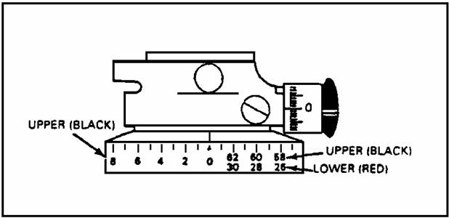

Figure 3-2. Aiming Circle Scales At “0”.

b. Use the azimuth knob to place the instrument reading (derived from the declination constant and azimuth of fire computation) on the azimuth and azimuth micrometer scales (Upper Motion). Set the first two digits on the azimuth scale and the last two on the azimuth micrometer scale (Figure 3-3). The reading on the azimuth and azimuth micrometer scale in the figure below is 3073.5.

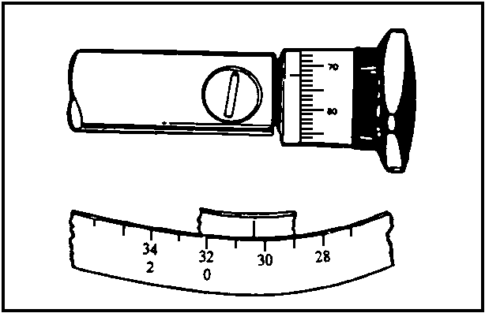

Figure 3-3. Placing the IR on the Aiming Circle.

5. Centering the magnetic needle.

a. Release the magnetic needle by rotating the magnetic needle locking lever (Figure 3-4) upwards until the needle floats freely.

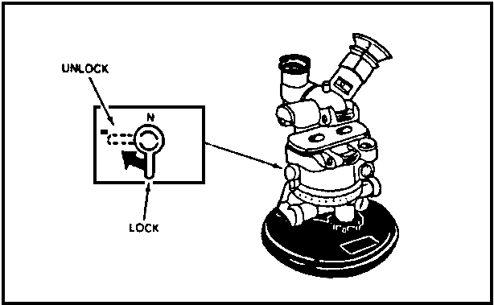

Figure 3-4. Magnetic Needle Lock.

b. Center the magnetic needle by looking through the magnifier (or top window) and rotating the orienting knob (Lower Motion) until the white groove of the magnetic needle (Figure 3-5) is centered on the reticle.

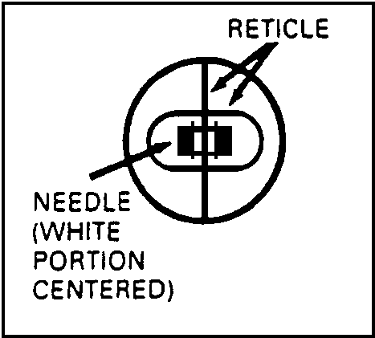

Figure 3-5. Centering Needle.

c. Once the needle has been centered, lock it by rotating the locking lever downward. (Figure 3-6).

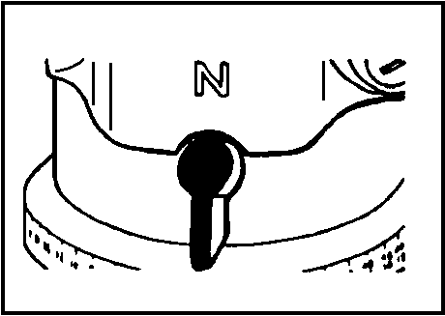

Figure 3-6. Needle Locked.

6. Laying the battery.

a. After locking the magnetic needle, rotate the azimuth knob (Upper Motion) until you can sight on the howitzer pantel. The reticle pattern in the eyepiece should be centered on the pantel of the howitzer being laid (Figure 3-7).

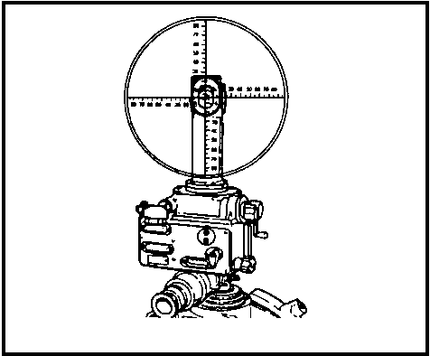

Figure 3-7. Sight Picture.

b. Read the deflection now showing on the azimuth and azimuth micrometer scales of the aiming circle. Read the first two numbers from the azimuth scale and the last two numbers from the azimuth micrometer scale (Figure 3-8), and announce this deflection to the gunner. In the figure below, the deflection is
"1250".

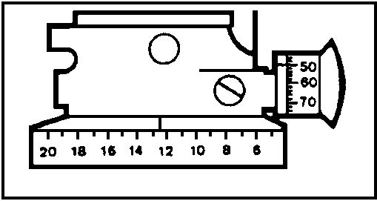

Figure 3-8. Deflection to Howitzer.

c. There are two sets of numbers on the azimuth scale. When the howitzers being laid have the M12-series sight, use the red numbers whenever they appear under the scribe mark. When the howitzers being laid have the M100 series sight, use the black numbers (Figure 3-9).

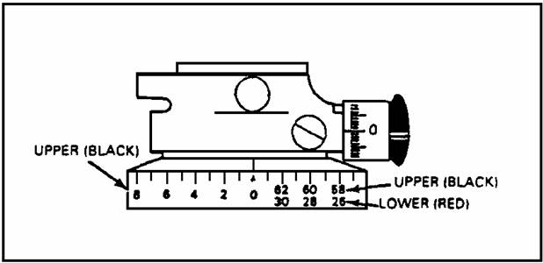

Figure 3-9. Red vs Black Scales.

d. As with all methods of laying a howitzer with the aiming circle, use the azimuth knob to sight on each howitzer pantel to determine the deflection. The commands for laying the howitzers are the same as discussed on page 2-5 and 2-6 of lesson 2. After the battery is laid, visually check to ensure the tubes are parallel. If time permits, have the gunners make a reciprocal check.

7. Measuring the azimuth. Upon completion of a mission for which survey control was not available, and before announcing "END OF MISSION", the FDC may request the XO to measure the azimuth.

a. When measuring the azimuth, the XO or platoon leader uses the aiming circle to measure the direction of the 0-3200 line of the weapon pantel. The steps for measuring the azimuth are as follows:

- At the aiming circle, the XO or platoon leader orients the 0-3200 line of the aiming circle generally parallel to the tube (number 3 in this case) of the weapon, and commands, "NUMBER 3, REFER, AIMING POINT THIS INSTRUMENT".

- The gunner measures the deflection to the aiming circle without moving the tube and announces, "NUMBER 3 AIMING POINT IDENTIFIED, DEFLECTION (so much)".

- The XO or platoon leader sets the announced deflection on the upper (recording) motion of the aiming circle.

NOTE: If the weapon has an M12-series sight, the referred deflection may have to be set off on the aiming circle by using the red numbers. When the deflection is set off, the line of sight of the aiming circle is oriented roughly toward the firing weapon.

- With the lower (nonrecording motion), the platoon leader sights on the panoramic telescope. The 0-3200 line is now parallel to the tubes of the firing weapon.

- With the upper (recording) motion the XO or platoon leader centers the magnetic needle on the aiming circle.

NOTE: Since the magnetic needle is used, the aiming circle must be set up away from magnetic attractions.

- The XO or platoon leader determines the reading on the aiming circle (instrument reading) and subtracts that value from the declination constant. The difference is the measured azimuth.

EXAMPLE: The XO has determined the instrument reading to be 2340 and the DC of his aiming circle to be 0200.

0200 DECLINATION CONSTANT
+6400
6600
-2340 INSTRUMENT READING
=4260 MEASURED AZIMUTH

- The XO announces: MEASURED AZIMUTH (4260--in this case) to the FDC.

NOTE: Before sending this azimuth to the FDC, the XO or platoon leader checks to see if there is any boresighting error on the number 3 gun, and applies the appropriate correction to the measured azimuth.

b. The executive officer or platoon leader now has two options:

- Relay the battery or platoon on the new azimuth and have the FDC correct all azimuth-of-lay data, or--

- Leave the battery or platoon laid on the original azimuth-of-lay, and have the FDC correct the azimuth of lay and gun location entries for BCS and/or BUCS.

c. The second option is preferred because the howitzers are not re-laid.

8. Measuring the orienting angle. When the battery occupies a position without directional control, the battery (as discussed earlier in this Lesson) is normally laid by the grid azimuth method. To prepare for common directional control by battalion, or by hasty survey, the executive officer (XO) designates an OS (usually where the aiming circle is currently located), and an EOL. Following set procedures, the XO measures the orienting angle and reports the orienting angle to the FDC.

a. Establishing the EOL. The EOL can be marked with an aiming post. It should be placed so it can easily be observed from the OS and at a minimum distance of 100 meters. This is the minimum distance for PADS to conduct survey operations.

b. Determining the orienting angle. To determine the orienting angle (Figure 3-10) the executive officer does the following:

- Has the howitzer (number 3 in this case) refer to the aiming circle by issuing the command, "NUMBER 3 REFER, AIMING POINT THIS INSTRUMENT".

- The number 3 gunner will turn the head of his pantel without moving the tube, and announce "Number 3, Aiming Point Identified, Deflection (so - much)".

- The XO places the deflection read by the number 3 gunner on the upper (recording) motion of the aiming circle.

- Using the lower (nonrecording) motion, the XO sights on the number 3 howitzer pantel.

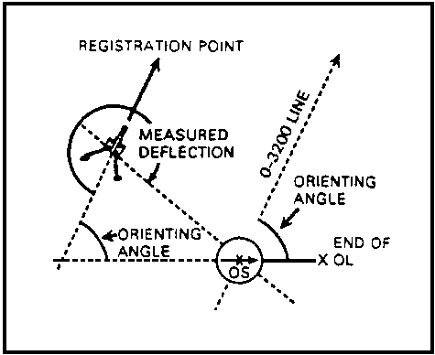

Figure 3-10. Measuring the Orienting Angle.

- With the upper (recording) motion sights on the EOL.

- The XO reads the orienting angle from the aiming circle and reports, "ORIENTING ANGLE (so much)", to the FDC.

c. When directional control is established, the executive officer or platoon leader does the following:

- Determines the orienting angle by using the orienting line established by survey.

- Determines the increase or decrease in the orienting angle.

- Using the backward azimuth rule, determines the azimuth on which the element was laid; and reports the azimuth to the FDC. The FDC will determine a new azimuth of lay based upon the surveyed azimuth and the orienting angle reported by the XO.

NOTE: The backward azimuth rule is a mathematical relationship used to apply equal change in angles used in the laying process. This rule establishes the relationship between three elements as follows: -- An increase in deflection causes an equal decrease in azimuth and an equal increase in orienting angle.

- XO re-lays the battery or platoon on the original azimuth of fire, or has the FDC correct the azimuth-of-lay and gun location entries for BCS and/or BUCS.

LESSON 3

PRACTICE EXERCISE

The following items will test your knowledge of the material covered in this part of the subcourse. There is only one answer for each item. When you have completed the exercise, check your answer with the key that follows. If you answer any item incorrectly, study again that part which contains the portion
involved.

1. As a rule, the aiming circle should be set up away from all--

A. trees and river beds.

B. magnetic attractions and electronic equipment.

C. roadways and trails.

2. The aiming circle must be set up at least ______ meters away from power lines.

A. 10

B. 75

C. 150

3. The aiming circle must be set up at least ______ meters away from railroad tracks, artillery pieces, tanks, vehicles and ammunition.

A. 10

B. 50

C. 75

D. 150

4. The aiming circle must be set up at least ______ meters away from personal weapons, and small metallic objects.

A. 10

B. 50

C. 75

Compute the following instrument readings (IR's).

AZIMUTH OF FIRE DECLINATION CONSTANT INSTRUMENT READING

5. 0300 0227 = _______

6. 0250 0524 = _______

7. 0100 0120 = _______

8. 0050 0023 = _______

9. 6350 0323 = _______

10. The 0-3200 line of the aiming circle is roughly oriented when the single 0 is--

A. facing away from you.

B. to your right.

C. facing toward you.

11. To orient the 0-3200 line in the direction of fire, use the--

A. azimuth micrometer knob.

B. elevation micrometer knob.

C. orienting knobs.

12. Which knob would you use to place the instrument reading on the aiming circle?

A. orienting knob

B. azimuth knob

C. leveling knob

D. elevation knob

13. To determine whether the magnetic needle is centered, look through the--

A. reticle window.

B. white groove pattern.

C. magnifier.

D. eyepiece.

14. Which scale of the aiming circle is used to read the first two numbers of deflection?

A. micrometer scale

B. elevation motion

C. nonrecording scale

D. azimuth scale

15. Which scale is used to read the last two numbers of deflection?

A. azimuth scale

B. lower motion

C. azimuth micrometer scale

D. nonrecording scale

16. Which numbers on the aiming circle are used when the pieces being laid have the M12-series sights?

A. horizontal numbers on the reticle pattern

B. vertical numbers on the reticle pattern

C. black numbers on the azimuth scale if the reading is over 3200 mils

D. red numbers on the azimuth scale if you see them

17. When measuring the azimuth, gun number 3 refers a deflection to the aiming circle. The XO will place that deflection on the UPPER (recording) motion and sight on the ________ with the LOWER motion.

A. EOL.

B. pantel of the howitzer that referred to him.

C. pantel of a different howitzer.

D. azimuth of fire.

18. Put the following steps of laying by grid azimuth in the correct sequence.

______ A. Set both scales of the aiming circle to 0.

______ B. Float and center the magnetic needle.

______ C. Use the DC to determine the instrument reading for the aiming
circle.

______ D. Read the deflection to the gunner.

______ E. Sight on the pantel of the howitzer that you intend to lay.

______ F. Look for the DC on the notation pad of the aiming
circle.

______ G. Set the instrument reading on the azimuth and azimuth micrometer
scales.

______ H. Roughly orient the 0-3200 line in the direction of fire.

19. While measuring the azimuth, the XO has determined the instrument reading to be 0165. The declination constant for his aiming circle is 0142. What azimuth will be announced to the FDC?

A. 6377

B. 0023

C. 3177

D. 6423

20. What command does the XO announce to have gun number 3 refer to the aiming circle?

A. NUMBER 3, REFER, AIMING POINT THIS INSTRUMENT.

B. NUMBER 3, AIMING POINT THIS INSTRUMENT.

C. NUMBER 3 ADJUST, AIMING POINT THIS INSTRUMENT.

21. What command will the number 3 gunner respond with?

A. NUMBER 3, IDENTIFIED.

B. DEFLECTION, (so much). NUMBER 3 AIMING POINT IDENTIFIED.

C. NUMBER 3, AIMING POINT IDENTIFIED, DEFLECTION (so much).

22. Once the XO has determined the azimuth, he will announce ______ to the FDC.

A. Measured Azimuth (so much)

B. Measured Deflection (so much)

C. Measured Location (so much)

23. When measuring the orienting angle, the XO will have one howitzer ______ to the aiming circle.

A. move

B. refer

C. shift

24. The XO will set the announced deflection on the ______ of the aiming circle.

A. outer motion

B. upper motion

C. lower motion

25. After the XO has determined the orienting angle, he will report it to the--

A. survey section.

B. battery commander.

C. fire direction center.

LESSON 3

PRACTICE EXERCISE

ANSWER KEY AND FEEDBACK

ITEM Correct Answer and Feedback

1. B. para 1a.

2. C. para 1a.

3. C. para 1a.

4. A. para 1a.

5. 6327. para 3a.

6. 0274. para 3a.

7. 0020. para 3a.

8. 6373. para 3a.

9. 0373. para 3a.

10. C. para 4a.

11. C. para 4a.

12. B. para 4b.

13. C. para 5b.

14. D. para 6b.

15. C. para 6b.

16. D. para 7a note.

17. B. para 7a.

18. A., H., F., C., G., B., E., D., pages 3-1 thru 3-7.

19. A. para 7a.

20. A. para 7a.

21. C. para 7a.

22. A. para 7a.

23. B. para 8b.

24. B. para 8b.

25. C. para 8b.

////////////////////////////////////////////////////////////////////////////////

9. Summary. The information in this lesson covered the procedures for laying the firing battery with the M2 aiming circle when survey data are not available. Procedures for computing instrument reading and detailed information for centering the magnetic needle were covered. This Lesson also presented information on when and how to measure the orienting angle and azimuth of fire. Remember, you measure the orienting angle when you have occupied a position without survey. You establish the EOL and measure the orienting angle in preparation for the arrival of the survey team. Measuring the azimuth is the
procedure in which we determine the grid azimuth on which a howitzer is pointed. To do this we must have a declinated aiming circle set up away from magnetic attractions. The procedures and mathematical computations for measuring the grid azimuth were all covered in detail. Ensure that you understand the information presented in this lesson before continuing to Lesson 4.

LESSON 4

LAYING THE FIRING BATTERY USING THE M2 COMPASS

OVERVIEW

LESSON DESCRIPTION:

This lesson will teach the procedures for laying a howitzer using the M2 compass.

LEARNING OBJECTIVE:

ACTION: Identify the procedures for laying a howitzer using a M2 Compass.

CONDITION: Given the material contained in this lesson.

STANDARD: Correctly answer all questions on the practice exercise at the end
of the lesson.

REFERENCE: The material contained in this lesson was derived from FM 6-50 and
other material approved for US Army field artillery instruction.

INTRODUCTION

To use the M2 Compass in firing battery/platoon operations, you must know how the instrument works, how it is declinated, and how it is used to measure an azimuth. Once you have mastered these tasks, you will be ready to lay a howitzer. If you are already familiar with the characteristics of the M2 Compass, the lesson will serve as a refresher.

1. M2 Compass.

a. General. The M2 compass (Figure 4-1) is an alternate instrument used for laying the battery/platoon. The unmounted magnetic compass is a multipurpose instrument used to obtain angle of site and azimuth readings.

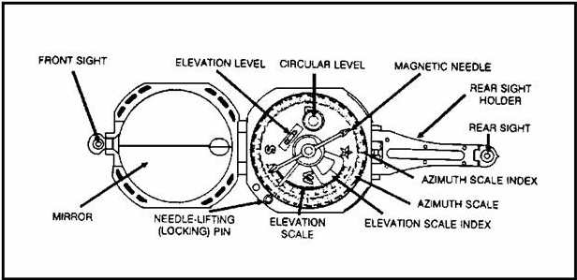

Figure 4-1. M2 Compass, top view.

b. Components. The components of the M2 compass are as follows:

- Azimuth Scale. The azimuth scale (Figure 4-1) is numbered every 200 mils from 0 to 6400 mils, is graduated every 20 mils, and can be read to an accuracy of 10 mils.

- Sights. The compass has front and rear leaf sights and a mirror in the cover (Figure 4-1) for sighting and reading angles.

- Levels. The compass is equipped with two types of levels: circular, (Figure 4-1) used for leveling the instrument before azimuth values are read; and tubular, (Figure 4-1) used with the elevation scale to measure angles of site.

- Angle-of-Site Mechanism. Rotation of the level lever causes the elevation level and the elevation scale index (Figure 4-1) to rotate as a unit. The index clamps against the bottom piece to keep the mechanism from moving unless it is actuated by the level lever.

- Magnetic Needle and Lifting Mechanism. The magnetic needle (Figure 4-1 [the white end of the needle]), shows a magnetic north direction for orienting purposes. The needle is delicately balanced and is jewel-mounted on a pivot to rotate freely. The magnetic needle reading is taken when the bubble mechanism is centered in the circular level. The lifting mechanism includes a needle-lifting (locking) pin and a needle-lifting lever. The lower end of the pin engages the lever. The upper end projects slightly above the body of the compass to engage the cover when it is closed, thereby automatically lifting the needle from its pivot and holding it firmly against the glass window.

Note: On newer model compasses, the needle is solid black, with the ends marked "N" for north, and "S" for south.

- Azimuth Scale Adjuster Assembly. The azimuth scale adjuster assembly rotates the azimuth scale to introduce the declination constant. (Declination Constant was discussed in Lesson 1. If you are unsure of the definition and procedures for computing a declination constant, study again that portion of Lesson 1 that covers the subject). Two teeth at the adjuster engage teeth on the underside of the azimuth scale. Thus, turning the adjuster with a screwdriver rotates the azimuth scale approximately 1800 mils. The scale is read against a fixed index under the rear sight hinge.

c. Declinating the M2 Compass.

- The procedure for declinating the M2 Compass from a surveyed declination station is as follows:

  - Set the M2 Compass on an aiming circle tripod over the orienting station (OS) and center the circular level.

  - Sight in on the known, surveyed azimuth marker.

  - Using the azimuth adjuster scale, rotate the azimuth scale until it is equal to the known surveyed azimuth.

  - After completing the preceding step, recheck the sight picture and azimuth to the known point. Once the sight
picture is correct and the azimuth reading is the same as
the surveyed data, the M2 is declinated. Once declinated
the accuracy of the compass is ± 10 mils.

- The procedure for field-expedient declination of the M2 Compass is as follows:

  - Using the azimuth adjuster scale, set off the grid-magnetic (G-M) angle (shown on the bottom of all military maps).

  - Once the G-M angle has been set off on the azimuth scale, the M2 Compass is declinated.

d. Measuring an Azimuth with The M2 Compass.

- To read the azimuth scale by reflection, hold the compass in both hands at eye level, with your arms braced against your body and the rear sight nearest your eyes. Place the cover at an angle of approximately 45º to the face of the compass (Figure 4-2) that the scale reflection can be viewed in the mirror. Level the instrument by viewing the circular level in the mirror. Sight on the desired object, and read the azimuth indicated on the reflected azimuth scale by the south-seeking (black or "S") end of the compass needle.

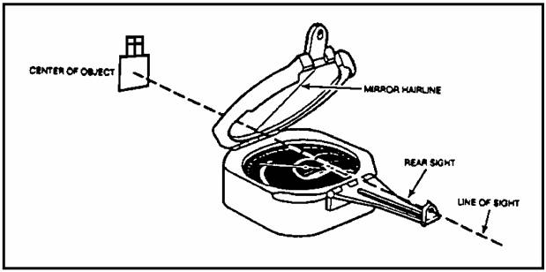

Figure 4-2. M2 Compass, Observer’s view.

2. When to lay the battery/platoon with the M2 Compass. There may be times when an aiming circle is not available and the battery must be laid. The most accurate method of laying without the aiming circle is with the M2 compass. When this method is used, only one howitzer is laid. The gunner on that howitzer then lays the rest of the battery reciprocally.

3. Positioning the M2 Compass. Normally, the battery XO, chief of firing battery, or gunnery sergeant would set up the compass and measure the deflection.

a. Before laying the battery, the M2 compass must be correctly set up. Since the compass contains a magnetic needle, it should be set up as far away as possible from all metallic objects and electronic equipment. Below are minimum distances the compass must be from electronic and metallic equipment:

  - At least 150 meters from power lines and electronic equipment.

  - At least 75 meters from railroad tracks, artillery, tanks, and vehicles.

  - At least 10 meters from barbed wire, personnel weapons, and small metallic objects.

b. The compass should be positioned where it can be seen and easily identified from the selected howitzer. The preferred position is the left front or the left rear of the adjusting howitzer (Figure 4-3).

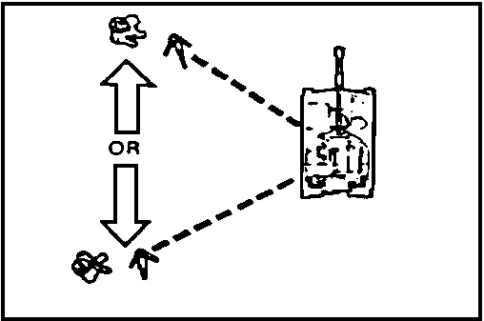

Figure 4-3. Positioning the Compass.

c. The compass can be positioned to the right front on certain weapon systems, however, this is not a preferred position (Figure 4-4). Do not place the compass to the right rear unless it is absolutely necessary. Due to the location of the pantel on the howitzer, this is the most difficult position to observe the compass (or aiming circle).

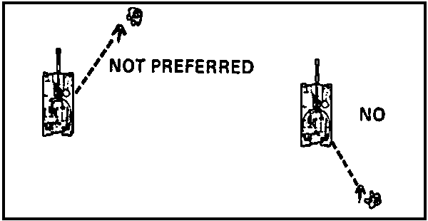

Figure 4-4. Non-Preferred Positions.

d. Position the compass on a level, stable object so the bubble will remain level during use. An excellent platform for this purpose is the AC tripod, a collimator cover or a mattock handle (Figure 4-5).

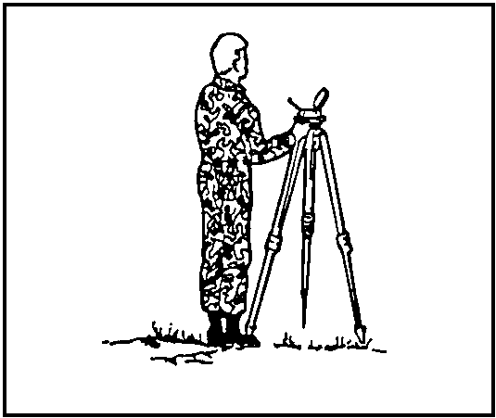

Figure 4-5. Using Aiming Circle Tripod as a Platform.

4. Measuring the azimuth to the howitzer.

a. You must measure the azimuth to the howitzer before you can lay the weapon. Place the compass on the AC tripod then level the compass (Figure 4-6).

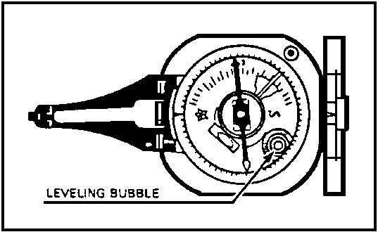

Figure 4-6. Leveling Bubble.

b. Measure the azimuth to the head of the howitzer pantel by rotating the compass until its sights are properly aligned on the pantel. Keep the compass level while sighting on the pantel to ensure maximum accuracy. Figure 4-7 below shows the correct sight alignment.

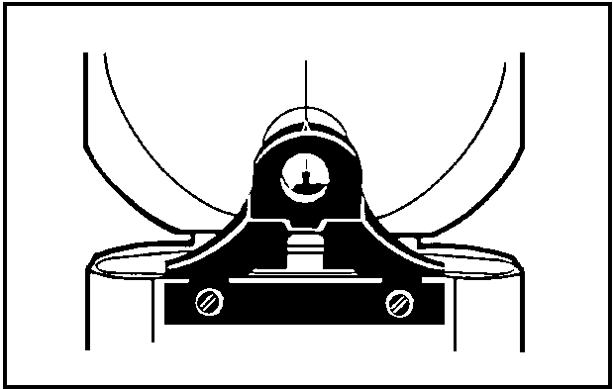

Figure 4-7. Correct Sight Picture.

c. After you have the correct sight picture, read the azimuth to the howitzer from the black ("S") end of the needle (Figure 4-8).

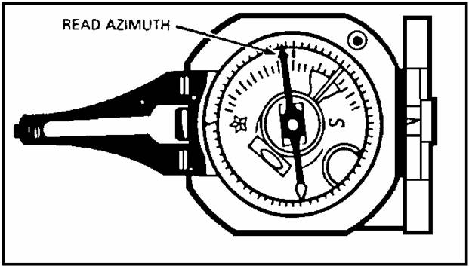

Figure 4-8. Reading Azimuth.

5. Determining the deflection for the howitzer.

a. The next step in laying the selected howitzer is to use the azimuth you have measured to compute a deflection for the gunner to place on the pantel. To compute the deflection, you must subtract the azimuth of fire (announced) from the azimuth to the howitzer (measured). An easy way to remember this is with
the memory aid SAM--

- S Subtract the

- A azimuth of fire from the

- M measured azimuth.

Announce the results as the deflection to the howitzer.

EXAMPLE: (1) Assume you measured an azimuth of 1275 mils (Figure 4-9).

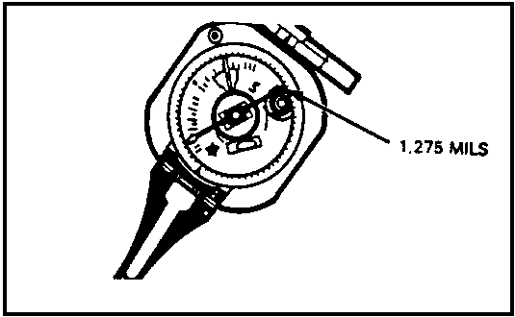

Figure 4-9. Measured Azimuth.

(2) After you measure the azimuth to the howitzer, record it for future use (Figure 4-10).

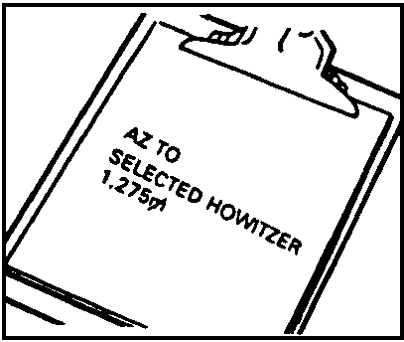

Figure 4-10. Recorded Azimuth.

(3) Subtract the azimuth of fire (announced) from the measured azimuth. The result of this computation is the deflection you will announce to the gunner.

AZIMUTH TO SELECTED HOWITZER
- AZ OF FIRE
= DEFLECTION

b. If the azimuth to the howitzer is smaller than the azimuth of fire, add 6400 to it before subtracting. You would use the formula shown below.

AZIMUTH TO SELECTED HOWITZER
+ 6400 mils
= SUM
- AZ OF FIRE
= DEFLECTION

c. Assume you need to lay the battery on an azimuth of fire of 4,800 mils, and that you measured an azimuth to the howitzer (with M100 sights) of 2520. The deflection to announce to the gun would be 4120.

2520 AZ TO SELECTED HOWITZER
+ 6400 mils (AZ TO HOWITZER IS LESS THAN AZ OF FIRE)
= 8920
- 4800 AZ OF FIRE
= 4120 DEFLECTION

d. If the pieces in your battery are equipped with the M12-series sights, the gunners cannot use this deflection. In this case, you would simply subtract 3200 before announcing the reading to the howitzer. You would announce a deflection of 0920 to the howitzer gunner for this type of sight.

4120
- 3200
= 0920

6. Using the proper commands to lay the howitzer.

a. After you have determined the deflection to announce to the gunner, command "NUMBER 3 (whichever howitzer you are using), ADJUST, AIMING POINT THIS INSTRUNENT, DEFLECTION (so much)."

b. The number 3 gunner then places the announced deflection on his pantel and traverses the tube until he has correctly sighted on the compass. Once he has sighted on the compass, he announces "NUMBER 3, AIMING POINT IDENTIFIED, DEFLECTION (so much)."

c. When this has been accomplished, the howitzer is laid and no more readings are required. You then command, "NUMBER 3 IS LAID".

7. Reciprocally laying the rest of the battery.

a. After the first howitzer is laid, (in this case, number 3) the gunner on that howitzer must lay the rest of the battery reciprocally. On the XO, CFB or GSG's command of "BATTERY ADJU8T, AIMING POINT NUNBER 3", the rest of the gunners will take up a sight picture on the number 3 howitzer pantel.

NOTE: Because of the position of the sight mounts and tubes of the M114A1/A2 and the M11OA2 howitsers, reciprocal laying may not be possible because the pantel of the howitser may be obscured.

b. To lay the rest of the battery, the gunner on the laying howitzer takes up a sight picture on the pantel of the howitzer that he identifies to lay and reads the deflection. The gunner of the howitzer being laid sets this deflection on his pantel and traverses the tube to sight on the laying howitzer pantel until that piece is laid. Here he uses the same procedure as if using
an aiming circle.

c. If the pieces are equipped with the M100-series sights (Figure 4-11), the laying howitzer gunner must either add or subtract 3200 from each reading. The LARS rule of "left add-right subtract", must be applied. If the piece is to the left, he will add 3200 before announcing the deflection. If the piece is to the right, he subtracts 3200. After the battery has been laid, the executive officer or gunnery sergeant makes a visual check to ensure the howitzer tubes are parallel.

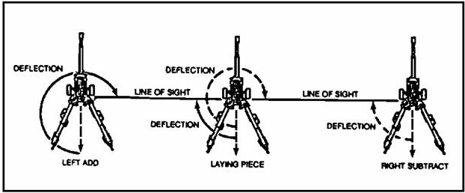

Figure 4-11. Reciprocal Laying (M100-series sight).

LESSON 4

PRACTICE EXERCISE

The following items will test your knowledge of the material covered in this part of the subcourse. There is only one answer for each item. When you have completed the exercise, check your answer with the key that follows. If you answer any item incorrectly, study again that part which contains the portion
involved.

1. When laying with the M2 compass it should be set up a minimum distance of ______ away from power lines and electronic equipment.

A. 150 meters

B. 75 meters

C. 10 meters

2. The minimum distance the compass should be set up from artillery pieces, tanks, and vehicles is--

A. 150 meters.

B. 75 meters.

C. 10 meters.

3. The minimum distance the compass should be set up from barbed wire, personal weapons, and small metallic objects is--

A. 150 meters.

B. 75 meters.

C. 10 meters.

4. The preferred location for setting up the compass is--

A. where it can be easily identified from the right rear of the howitzers.

- where it can be easily identified from the right front of the
howitzers.

- where it can be easily identified from the left front of the adjusting
piece.

5. Unless absolutely necessary, the compass should never be positioned to the-

A. right front of the howitzer.

B. right rear of the howitzer.

C. left rear of the howitzer.

6. A location which can be used on certain weapon systems, but is not preferred, is to the-

A. left rear of the howitzer.

B. left front of the howitzer.

C. right front of the howitzer.

7. An excellent platform (if available) on which to set up the compass is the-

A. aiming post.

B. aiming circle tripod.

C. camouflage net pole.

8. Before the azimuth to the howitzer pantel can be accurately measured, the compass must be properly--

A. set up.

B. declinated.

C. leveled.

D. all of the above.

9. The azimuth to the howitzer is measured by aligning the compass sights on the--

A. pantel.

B. collimator.

C. aiming circle.

10. To ensure maximum accuracy, keep the compass ______ while using it.

A. covered

B. canted

C. leveled

11. Once the azimuth to the howitzer has been measured, it is read from the ______ end of the compass needle.

A. red

B. white

C. black

12. To obtain a deflection when laying by M2 compass, the compass operator must--

A. subtract the azimuth of fire from the azimuth measured to the howitzer.

B. add the azimuth of fire to the azimuth measured to the howitzer.

C. subtract the azimuth of fire from the declination constant.

13. If the azimuth of fire is larger than the measured azimuth to the howitzer, add ______ before subtracting.

A. 6400

B. 1600

C. 4800

14. If the battery is equipped with the M12-series sights, you may have to subtract ______ from the deflection.

A. 6400

B. 4800

C. 3200

Use the information provided below to compute the deflection. Assume that the howitzers are equipped with the M12-series sights.

MEASURED AZ TO HOWITZER AZ OF FIRE DEFLECTION

15. 3279 1200 =________

16. 4560 4750 =________

17. 2810 5350 =________

18. 6350 0050 =________

19. 1100 6300 =________

Now assume that the howitzers are equipped with the M100-series sights.

AZ TO HOWITZER AZ OF FIRE DEFLECTION

20. 0123 6350 =________

21. 4559 3200 =________

22. 6320 6300 =________

23. 5472 6400 =________

24. 1893 3800 =________

25. Which of the following commands is given after the deflection to lay the howitzer is determined?

A. BATTERY ADJUST, AIMING POINT THIS INSTRUMENT.

B. NUMBER 3, AIMING POINT THIS INSTRUMENT, REFER.

C. BATTERY ADJUST ON NUMBER 3, LAY PARALLEL.

D. NUMBER 3 ADJUST, AIMING POINT THIS INSTRUMENT, DEFLECTION
(so much).

26. Once the adjusting gunner has sighted on the M2 compass, he announces--

A. NUMBER 3 IS LAID.

B. NUMBER 3, AIMING POINT IDENTIFIED, DEFLECTION, (so much).

C. NUMBER 3, REFER.

D. NUMBER 3, AIMING POINT IDENTIFIED.

27. When the number 3 howitzer has been laid, the command given to the rest of the battery for reciprocal laying is--

A. BATTERY ADJUST, AIMING POINT THIS INSTRUMENT.

B. BATTERY, AIMING POINT THIS INSTRUMENT, REFER.

C. BATTERY ADJUST, AIMING POINT NUMBER 3.

D. BATTERY ADJUST, AIMING POINT BASE PIECE, DEFLECTION (so much).

28. When the gunners receive the command to start laying reciprocally, the aiming point the other gunners will use is the--

A. number 3 howitzer pantel.

B. M2 compass.

C. distant aiming point.

D. aiming circle.

29. Once the battery is laid, a visual check must be made to ensure that--

A. all gunners can see the aiming point.

B. all howitzer tubes are parallel.

C. all howitzers are ready to fire.

D. all pantels are emplaced.

Put the following steps to lay the battery with the M2 compass in the correct sequence; then place the correct sequence number in the space provided.

- ________ A. Command NUMBER (so-and-so) ADJUST, AIMING POINT THIS
INSTRUMENT, DEFLECTION (so much).

________ B. Center the compass bubble.

________ C. Read and record the azimuth to the howitzer.

________ D. Declinate the compass, and position it where it can be seen by
the howitzer gunner.

________ E. The howitzer gunner sets off deflection and ________ F.
Measure the azimuth to the howitzer to determine deflection.

________ G. Use the azimuth measured to determine deflection.

________ H. Command BATTERY ADJUST, AIMING POINT NUMBER (so-and-so).

________ I. Check to ensure that all howitzer tubes are parallel.

________ J. Announce NUMBER (so-and-so) is Laid.

LESSON 4

PRACTICE EXERCISE

ANSWER KEY AND FEEDBACK

ITEM Correct Answer and Feedback

1. A. para 3a.

2. B. para 3a.

3. C. para 3a.

4. C. para 3b.

5. B. Figure 4-4.

6. C. Figure 4-4.

7. B. para 3d.

8. D. para 1c.

9. A. para 4b.

10. C. para 4b.

11. C. para 4c.

12. A. para 5a.

13. A. para 5b.

14. C. para 5d.

15. 2079m, para 5a thru 5d.

16. 3010, (Add 6400 and subtract 3200 for M12-series.) para 5a thru 5d.

17. 0660, (Add 6400 and subtract 3200 for M12-series.) para 5a thru 5d.

18. 3100, (Subtract 3200 for M12-series.) para 5a thru
5d.

19. 1200, (Add 6400.) para 5a thru 5d.

20. 0173, para 5a thru 5d.

21. 1359, para 5a thru 5d.

22. 0020, para 5a thru 5d.

23. 5472, para 5a thru 5d.

24. 4493, para 5a thru 5d.

25. D. para 6a.

26. B. para 6b.

27. C. para 7a.

28. A. para 7b.

29. B. para 7c.

30. D., B., F., C., G., A., E.,J.,H.,I.
////////////////////////////////////////////////////////////////////////////////

8. Summary. In Lesson 4 you learned how to use the M2 Compass to lay a battery. You have learned how to emplace the M2 compass, measure the azimuth to a selected howitzer, calculate the deflection, and command the laying of a selected howitzer and the remainder of the battery. Ensure that you understand all the information in this lesson before continuing to Lesson 5.

LESSON 5

LAYING THE FIRING BATTERY BY
AIMING POINT-DEFLECTION METHOD

OVERVIEW

LESSON DESCRIPTION

This Lesson teaches the procedures for laying the battery using the aiming point-deflection method.

LESSON OBJECTIVE:

ACTION: Identify the procedures for laying by the aiming point-deflection
method.

CONDITION: Given the material contained in this lesson.

STANDARD: Correctly answer all questions on the practice exercise at the end
of the lesson.

REFERENCES: The material contained in this lesson was derived from FM 6-50 and
other publications approved for US Army field artillery
instruction.

INTRODUCTION

The aiming point-deflection method of laying the battery is used primarily during a rapid occupation of a position, however, it can also be used to lay the battery during a deliberate occupation of a firing position when an aiming circle or an M2 compass are unavailable.

1. When to lay the battery using the Aiming point-deflection method.

a. There are emergency situations when the firing battery must rapidly occupy a position and provide immediate fires on a target. In a situation such as this you can lay the battery without an aiming circle or M2 compass. The method used in this situation is the aiming point-deflection method of lay. The only materials needed are a map, coordinate scale, protractor, pencil and paper, az of fire, and distant aiming point (DAP). Although this method of laying the battery is not as accurate as laying by aiming circle or M2 compass, it can be used when speed is essential. In this situation the FDO, battery XO, chief of
firing battery, or gunnery sergeant select an aiming point and compute the deflection to lay the battery.

b. There are six steps to laying by the aiming point-deflection method. These steps must be taken in order.

- Select a distant aiming point (DAP).

- Measure the azimuth to the DAP.

- Determine the azimuth of fire.

- Compute the back-azimuth of fire.

- Compute the deflection.

- Use the correct commands to lay the battery.

2. Choosing a distant aiming point.

a. When it becomes necessary to lay the battery by the aiming point-deflection method, you must first choose a DAP and measure an azimuth to it from the battery position.

b. Whenever possible, the distant aiming point should, be located to the flank of the battery position. When this method of laying the battery is used, the battery sheaf (impact of the rounds fired) will begin to converge if the aiming point is to the front of the position and diverged if the aiming point is to the rear. The amount of this convergence or divergence will increase as the target range increases.

c. The DAP must be at least 1500 meters away from the battery position and easily identified on both a map and on the ground.

3. Measuring the azimuth to the DAP. Determine the azimuth to the DAP from the center of the battery or platoon. Scale the azimuth from a map or measure it with a declinated compass.

4. Determine the azimuth of fire. The azimuth of fire is also scaled from the map, after plotting the target and the proposed firing position.

5. Determine the back azimuth of fire. To determine the back-azimuth of fire, locate the target on the map, and measure the azimuth of fire from the plotted battery position. Record this azimuth, and determine the back azimuth of fire by adding or subtracting 3200 (Figure 5-1).

REMEMBER THIS RULE: If the azimuth is less than 3200, add 3200 to determine the back azimuth. If the azimuth is greater than 3200, subtract 3200 to determine the back azimuth.

Example: AZIMUTH OF FIRE 0500
ADD + 3200
BACK AZIMUTH OF FIRE = 3700

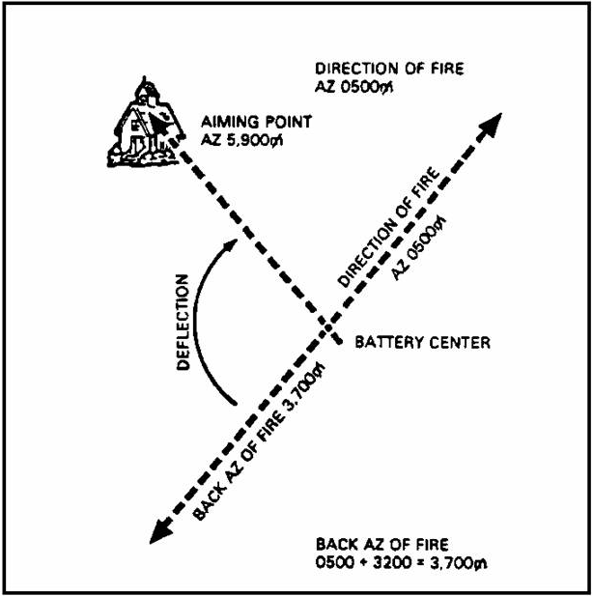

Figure 5-1. Back Azimuth of Fire.

6. Determining deflection. An excellent memory aid for the aiming point-deflection method is AP-BAF.

a. Once you determine the back azimuth of fire, use it to determine the deflection (df) to the DAP. Compute the deflection by subtracting the back-azimuth of fire from the azimuth to the aiming point (Figure 5-2).

Example: AZIMUTH TO THE AIMING POINT 5900
MINUS BACK-AZIMUTH OF FIRE - 3700
DEFLECTION TO DAP 2200

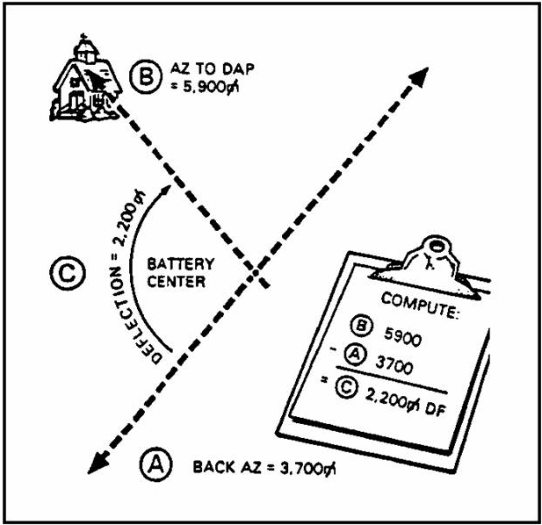

Figure 5-2. Deflection.

b. If the back azimuth of fire is greater than the azimuth to the DAP, add 6400 to the azimuth to the DAP before subtracting the back-azimuth of fire (Figure 5-3).

Example: If the azimuth to the DAP is 1250 mils and the back-azimuth of fire is 3700, the deflection for the howitzers would be 3950.

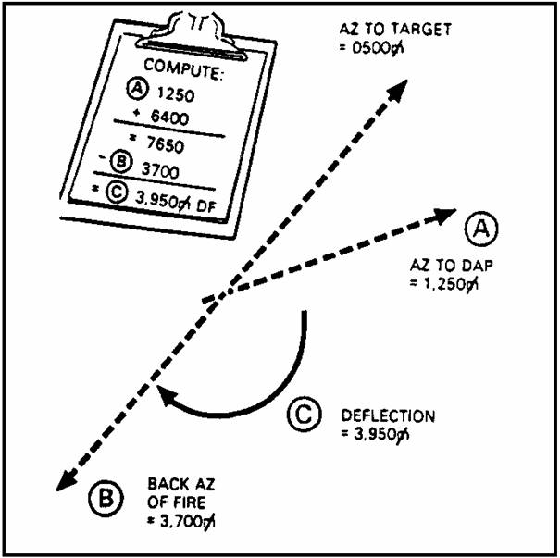

Figure 5-3. AZ of Fire Greater Than AZ To DAP.

c. If the howitzers are equipped with the M12-series sights (M1O1A1 105-mm howitzer and M114A1/A2 155-mm howitzer), the gunners cannot set a deflection of 3950 on their pantels. To apply the deflection to these sights, you must subtract 3200 before announcing it to the gunners.

Example: 3950 DEFLECTION
- 3200
= 0750 DEFLECTION FOR M12-SERIES SIGHTS.

For M100-series sights, the announced deflection (3950) can be placed on the pantel.

7. Using the proper commands to lay the battery.

a. Once you determine the deflection, announce it to the gunners using the command, "BATTERY ADJUST, AIMING POINT so-and-so), (DAP location), DEFLECTION (so much)".

b. Upon receiving this command, each gunner places the announced deflection on his pantel and traverses the tube until he sights on the DAP. When he has sighted on the DAP, he will announce "NUMBER so-and-so), AIMING POINT IDENTIFIED, DEFLECTION (so much)". When you receive this report from all gunners, announce that the battery is laid.
LESSON 5

PRACTICE EXERCISE

The following items will test your knowledge of the material covered in this part of the subcourse. There is only one answer for each item. When you have completed the exercise, check your answer with the key that follows. If you answer any item incorrectly, study again that part which contains the portion
involved.

1. The aiming point-deflection method may be used in the absence of a (an) --

A. aiming circle.

B. compass.

C. both A and B.

2. When laying by the aiming point-deflection method the best location for the DAP is--

A. to the front of the battery.

B. to the rear of the battery.

C. to the flank of the battery.

3. Before laying by the aiming point-deflection method, measure the azimuth to the DAP from the--

A. center of the battery position.

B. flank of the battery position.

C. rear of the battery position.

4. When laying by the aiming point-deflection method, what is the minimum distance a DAP should be from the position?

A. 1000 meters.

B. 1500 meters.

C. 2000 meters.

Determine the back azimuth of fire in each exercise below.

AZIMUTH OF FIRE BACK AZIMUTH

5. 3197 ___________

6. 5420 ___________

7. 0502 ___________

8. 3201 ___________

9. 4620 ___________

Use the information below to determine deflection. Assume that the howitzers are equipped with the M100-series sights.

AZ TO DAP BACK AZ OF FIRE DEFLECTION

10. 5720 3205 _________

11. 3413 4702 _________

12. 3973 2214 _________

13. 4851 4793 _________

14. 0223 5499 _________

Now, assume that the howitzers are equipped with M12-series sights.

AZ TO DAP BACK AZ OF FIRE DEFLECTION

15. 1173 2473 _________

16. 4820 4752 _________

17. 0123 3301 _________

18. 4567 1809 _________

19. 3221 0103 _________

You are laying the battery using the aiming point-deflection method. Put the following steps in correct sequence by placing the step number in the space provided.

20. _____ A. Determine the back azimuth of fire.

_____ B. Command THE BATTERY IS LAID.

_____ C. Plot the target.

_____ D. Determine the azimuth of fire.

_____ E. Compute the deflection.

_____ F. Announce the deflection to the guns.

_____ G. Measure the azimuth to the DAP.

LESSON 5

PRACTICE EXERCISE

ANSWER KEY AND FEEDBACK

ITEM Correct Answer and Feedback

1. C. para 1a

2. C. para 2.

3. A. para 3.

4. B. para 2c

5. 6397 para 5.

6. 2220 para 5.

7. 3702 para 5.

8. 0001 para 5.

9. 1420 para 5.

10. 2515 para 6a

11. 5111 para 6a

12. 1759 para 6a

13. 0058 para 6a

14. 1124 para 6a

15. 1900 para 6c

16. 0068 para 6c

17. 0022 para 6c

18. 2758 para 6c

19. 3118 para 6c

20. G, C, D, A, E, F, B.

////////////////////////////////////////////////////////////////////////////////

8. Summary. In this Lesson 5 you learned the primary method oflaying the battery during an emergency occupation. This method is the aiming point-deflection method of lay. You have learned the procedures for selecting the distant aiming point and how to determine the back azimuth of fire. You also learned how to compute and announce the deflection to the guns. Ensure that you
understand all the material presented in this lesson before continuing to Lesson 6.
LESSON 6

LAYING THE FIRING BATTERY
USING THE HOWITZER BACK-LAY METHOD

OVERVIEW

LESSON DESCRIPTION

This lesson teaches the procedures for laying the battery/platoon by the howitzer back-lay method of lay.

LESSON OBJECTIVE:

ACTION: Identify the procedures for laying the battery/platoon by the
howitzer back-lay method of lay.

CONDITION: Given the material contained in this lesson.

STANDARD: Correctly answer all questions on the practice exercise at the end
of the lesson.

REFERENCES: The material contained in this lesson was derived from FM 6-50 and
other material approved for US Army field artillery instruction.

INTRODUCTION

There may be situations when your firing battery must rapidly occupy a position and provide immediate fires on a target. In this situation you should use the howitzer back-lay method to lay the battery.

1. When to use the howitzer back-lay method. Normally the howitzer back-lay method is used during an emergency fire mission. This method should be used only if it is impossible to use the grid azimuth and distant aiming point methods. To lay the battery by the howitzer back-lay method, an aiming circle and an M2 compass are needed.

2. Procedures for using the howitzer back-lay method.

a. Determine the azimuth of fire. In this situation, an emergency fire mission is received by the Fire Direction Center (FDC) while in route to a new position. The FDC determines the azimuth of fire by using the BCS or BUCS hip-shoot procedures or by scaling it from a map after plotting the target and the
proposed firing position. This data is passed on to the FDO/XO.

b. Mark the azimuth of fire. Upon occupation of position, the FDO/XO aligns his vehicle in the general direction of fire. The FDO/XO then marks the azimuth of fire (Figure 6-1) for the adjusting piece. (This is normally accomplished by using a strip of engineer tape, or two stakes aligned in the direction of fire by an M2 compass). The FDO/XO must ensure the adjusting piece
positions alongside (SP [parallel]) or over (towed [parallel])the azimuth marker as other howitzers are positioned on line. The adjusting piece is considered to be layed as soon as it is aligned with the engineer tape or stakes.

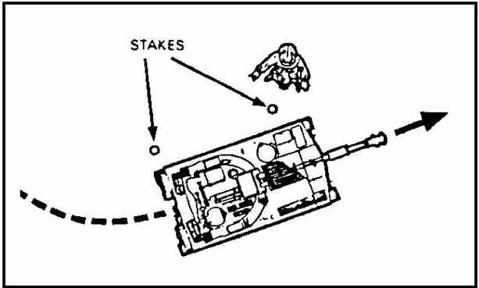

Figure 6-1. Aligning Howitzer in Direction of Fire.

NOTE: For a towed weapon, the first stake should be placed in the position where the pantel will be and the second stake should be placed as a guide stake for the howitzer tube.

c. While the FDO/XO is marking the azimuth of fire, the following actions are taking place simultaneously:

- The platoon sergeant takes the aiming circle to the left flank of the firing position. He sets up the aiming circle, levels it, and orients the 0-3200 line (Figure 6-2) in the approximate direction of fire. He then prepares to accept a referred reading from the adjusting howitzer.

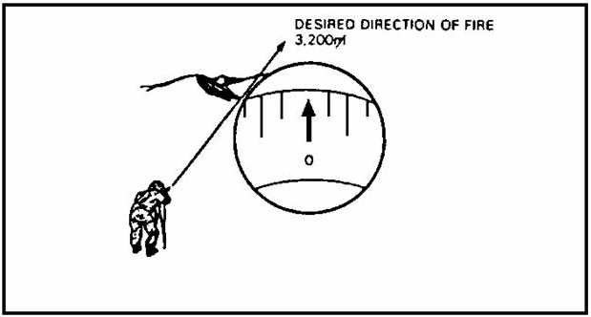

Figure 6-2. Orienting the Aiming Circle.

- The chief computer positions the FDC vehicle so that the rear of the vehicle is facing the line of metal. This allows the FDC to observe the state of readiness of the firing sections and facilitates the announcement of voice commands.

- As the adjusting piece is preparing to fire the first round, all other howitzers are pulling on line. Positioning is critical. Each howitzer section chief must position his howitzer so the line of sight is not impaired by another howitzer and his gunner can see the aiming circle.

- The FDC announces the firing data (charge and quadrant) to the adjusting piece, and the first round is fired. Immediately upon firing the first round, the gunner of the adjusting piece establishes an aiming point by placing an aiming stake midway between his pantel and the aiming circle.

d. Orienting the aiming circle to the line of fire.

- After the adjusting piece has fired the initial round of adjustment, the platoon sergeant commands, "NUMBER so-and-so)
(adjusting piece) REFER, AIMING POINT THIS INSTRUMENT".

- When the gunner of the adjusting piece receives this command, without traversing the tube, he takes up a good sight picture on the aiming circle and reads the deflection on the pantel to the platoon sergeant. If voice commands are a problem, the deflection should be sent to the circle by a runner.

- The platoon sergeant sets the referred deflection on the azimuth and azimuth micrometer (upper motion) of the aiming circle, and by using the orienting knobs (lower motion) sights on the pantel (Figure 6-3) of the adjusting piece.

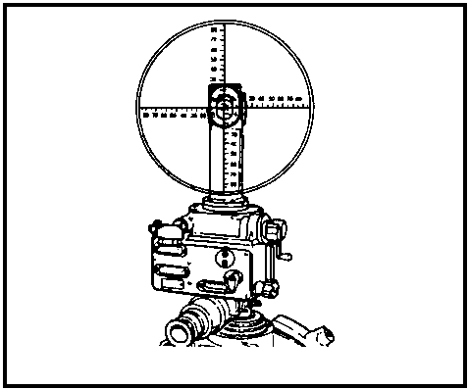

Figure 6-3. Sight Picture.

NOTE: If the howitzers are equipped with the M100-series sights, use the black numbers on the azimuth scale. For the M12-series sights, use the numbers (red or black) will place the line of sight of the aiming circle on the pantel.

- The platoon sergeant is now ready to lay the remainder of the firing battery.

e. Laying the remainder of the battery.

- Using the upper motion of the aiming circle, the platoon sergeant sights on the pantel and announces a deflection to the howitzer.

- Each gunner identifies the aiming point and receives his deflection. The deflection is set off, the tube is traversed until the line of sight is back on the aiming circle, and the piece is layed. In the interest of time, only one reading is given to each howitzer and there are no rechecks. If the initial target location was good and the FDO/XO laid out the azimuth tape (stakes), the second volley of rounds may be fired for effect.

- An aiming point is then established for each weapon. As with the adjusting piece, aiming points are normally established by placing an aiming stake half way between the howitzer sight and the aiming circle.

- The platoon sergeant should remain at the aiming circle during the fire mission in case a weapon requires relaying or the lay of the battery needs to be refined.

LESSON 6

PRACTICE EXERCISE

The following items will test your knowledge of the material covered in this part of the subcourse. There is only one answer for each item. When you have completed the exercise, check your answer with the key that follows. If you answer any item incorrectly, study again that part which contains the portion
involved.

1. The howitzer back-lay method is used to lay the battery when-

A. there is no grid azimuth available.

B. there is no DAP available.

C. both A and B. above.

2. The azimuth of fire is determined by the--

A. XO.

B. FDC.

C. survey section.

3. During the howitzer back-lay method, the FDO/XO aligns two stakes or a piece of engineer tape on the--

A. azimuth of the EOL.

B. azimuth of the DAP

C. azimuth of fire.

4. The deflection received from the adjusting piece gunner, is set on the aiming circle with the--

A. elevation knob.

B. azimuth knob.

C. orienting knob.

5. After you have set the initial deflection on the aiming circle, sight on the pantel by using the--

A. orienting knob.

B. azimuth knob.

C. elevation knob.

6. What should you do after you have set up the aiming circle and oriented it in the direction of fire?

A. Lay the remainder of the battery.

B. Sight on the pantel.

C. Command NUMBER (so-and-so) REFER, AIMING POINT THIS INSTRUMENT.

D. Direct the crew to set out an aiming point.

7. What does the adjusting piece gunner use as an aiming point once the aiming circle has been laid?

A. the collimator

B. the DAP

C. the aiming posts

D. the aiming circle and aiming post

8. Once the aiming circle has been laid, direct the adjusting piece crew to--

A. put out a orienting line marker.

B. put an aiming post between the pantel and the aiming circle.

C. place an aiming post halfway between the adjusting piece and the number
2 and number 4 gun.

Put the following steps into the correct sequence.

- _______ A. Command NUMBER (so-and-so), REFER, AIMING POINT THIS
INSTRUMENT.

_______ B. FDO directs the adjusting piece into position.

_______ C. Use the azimuth knob to place the deflection on
the aiming circle.

_______ D. FDO aligns two stakes on the azimuth of fire.

_______ E. Use the orienting knob to sight on adjusting
piece pantel.

_______ F. Command BATTERY ADJUST, AIMING POINT THIS
INSTRUMENT.

_______ G. Adjusting piece fires an adjusted round.

_______ H. Gunner commands NUMBER (so-and-so), AIMING POINT IDENTIFIED,
DEFLECTION (so much).

_______ I. Adjusting piece crew to set out an aiming post.

_______ J. Use the azimuth knob to lay the remainder of the
battery.

LESSON 6

PRACTICE EXERCISE

ANSWER KEY AND FEEDBACK

ITEM Correct Answer and Feedback

1. C. para 1.

2. B. para 2a.

3. C. para 2b.

4. B. para 2d.

5. A. para 2d.

6. C. para 2d.

7. D. para 2d.

8. B. para 2d.

9. D., B., G., A., H., C., E., I., F., J.,

/////////////////////////////////////////////////////////////////

3. Summary. The howitzer back-lay method, which is the method of laying the battery during an emergency occupation when a distant aiming point is not available, was discussed in this lesson. Procedures for orienting the initial howitzer were discussed. An M2 aiming circle must be available to lay the
remainder of the battery. Ensure you understand all the material presented in this subcourse before taking the final exam.

